
As of 29 April 2022
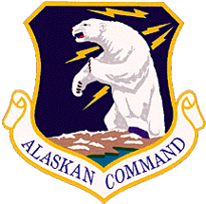



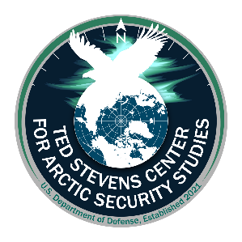

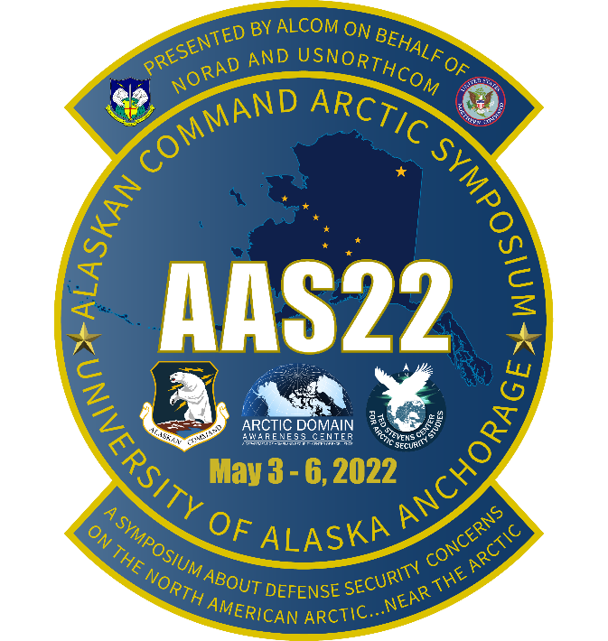

Presented on behalf of NORAD and USNORTHCOM

Alaskan Command Hosts
Arctic Symposium 2022
3 to 6 May 2022
Anchorage, Alaska

Available Speaker Biographies

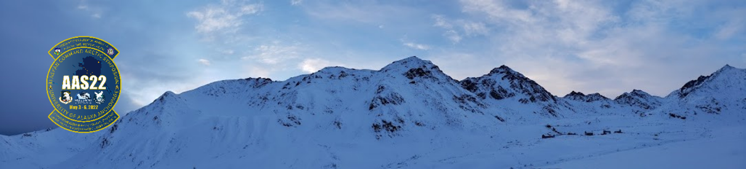
Introduction and Overview
In support of United States Northern Command (USNORTHCOM), Alaskan Command (ALCOM) (a subordinate unified command reporting to USNORTHCOM), located at Joint Base Elmendorf-Richardson (JBER) Alaska, is honored to host Arctic Symposium 2022 (AAS22) a symposium about the Arctic, conducted near the Arctic. ALCOM AAS22 is planned principally as an in-person event but will have a number of virtual participation options from 3-6 May in Anchorage Alaska.

Arctic Symposium 2022 Participant Biographies

In support of NORAD and United States Northern Command (USNORTHCOM), Alaskan Command (ALCOM) (a subordinate unified command reporting to USNORTHCOM) is hosting a four-day Arctic Symposium 2022 (AAS22) on 3-6 May 2022.

The following are biographies of the Arctic Symposium’s speakers and invited participants listed in Alphabetical order.

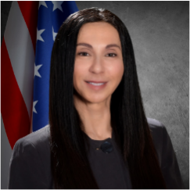
Dr. Lillian "Doc" Alessa
President's Professor
University of Idaho
Moscow, Idaho
Chief Scientist, USSOCOM, MacDill AFB, Florida
alessa@uidaho.edu

Lilian “Doc” Alessa, is president’s professor at the University of Idaho and affiliate faculty with George Mason and Texas A&M universities. She serves as chief scientist for the U.S. Special Operations Command Joint Special Operations University. Her federal service spans decades including as a defense intelligence senior level special adviser to the Office of the Director for National Intelligence and deputy chief of global strategies with the Homeland Security Department. She has close to 30 years of arctic experience working the joint, interagency, intergovernmental, multinational and commercial sectors across Canada and the United States on security, defense and the resilience of integrated systems.

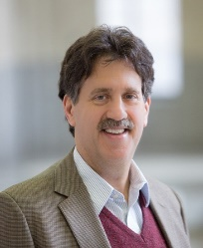
Ambassador David Balton
Executive Director, Arctic Executive Steering Committee
White House Office of Science and Technology Policy
Washington, DC
David.A.Balton@ostp.eop.gov

David Balton is the Executive Director of the U.S. Arctic Executive Steering Committee, which advances and coordinates and U.S. policies and activities in the Arctic region. He previously served as the Deputy Assistant Secretary for Oceans and Fisheries in the U.S. Department of State, attaining the rank of Ambassador in 2006. He was also a Senior Fellow at the Woodrow Wilson International Center for Scholars. During the U.S. Chairmanship of the Arctic Council (2015-2017), Ambassador Balton served as Chair of the Senior Arctic Officials. His prior Arctic Council experience included co-chairing the Arctic Council Task Forces that produced the 2011 Agreement on Cooperation on Aeronautical and Maritime Search and Rescue in the Arctic and the 2013 Agreement on Cooperation on Marine Oil Pollution Preparedness and Response in the Arctic. He separately chaired negotiations that produced the 2021 Agreement to Prevent Unregulated High Seas Fisheries in the Central Arctic Ocean.


Inga Banshchikova
Policy Researcher, Sustainable Development Group Coordinator
WWF US Arctic Program, WWF Global Arctic Programme
Anchorage, Alaska
inga.banshchikova@wwfus.org

Inga Banshchikova serves as a Policy Researcher in the World Wildlife Fund US Arctic Program and Sustainable Development Group Coordinator in the World Wildlife Fund Global Arctic Program. Together with the WWF team, Inga is working to promote biodiverse and resilient Arctic, supporting WWF efforts to prioritize sustainability in Arctic shipping, energy, and economic development. Inga’s professional focus is on mitigation of the risks from industry activities, relying on western science with Indigenous knowledge in the US and internationally. Inga is engaged in multiple international organizations like IMO, PAME, and Arctic Council’s working groups. Inga holds a bachelor’s degree in International Relations and two master’s degrees in International Law and Public Policy.

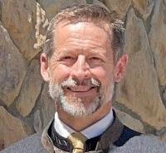
Brig Gen (Ret) Dieter “Deets” Bareihs
Contract Manager, ACT-I
Ted Stevens Center for Arctic Security Studies
Crystal City, Virginia
dbareihs@act-i.com

Brig Gen Dieter “Deets” Bareihs, United States Air Force (Ret, is the Contract Manager for Advanced Concepts and Technologies, International LLC, in support of the Ted Stevens Center for Arctic Security Studies. He previously served as Deputy Director of the George C. Marshall European Center for Security Studies, after more than 29 years in the Air Force. While on active duty, Brig Gen (Ret) Bareihs was twice assigned to Eielson Air Force Base, North Pole, AK as F-16 pilot, then Commander of the 18th Fighter Squadron. As Director of Plans, Programs and Analysis for United States Air Forces in Europe and Air Forces Africa, he participated in the study which laid the foundation for the current Air Force Arctic Strategy.

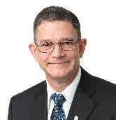
RADM Matt Bell, USCG (Ret)
Dean, School of Arctic and Climate Studies
Ted Stevens Center for Arctic Security Studies
Anchorage, Alaska

Former Commander, Seventeenth Coast Guard District, Juneau, AK, Rear Admiral (Ret.) Matthew T. Bell Jr. joined the Ted Stevens Center for Arctic Security Studies as Dean On 25 April 2022. He is responsible for the executive education program designed with the end goals of protecting the U.S. homeland, maintaining a favorable balance of power in the region, and promoting a shared approach to regional security and respect for the existing rules-based order. His thirty-six year Coast Guard career includes numerous operational tours in Alaska, including two command afloat assignments in Kodiak and most recently as the Commander, 17th Coast Guard District in Juneau where he was responsible for Coast Guard operations throughout Alaska, the North Pacific Ocean, Bering Sea and Arctic Ocean. Mr. Bell is a 1984 graduate from Northern Arizona University, earning a Bachelor of Science in Chemistry. He entered the Coast Guard in 1985 through Recruit Training Center Cape May and received his commission in 1986 upon graduation from Officer Candidate School. He holds a Master of Science in Chemistry awarded by Northern Arizona University in 1993 and is a graduate of Harvard University, National Preparedness Leadership Initiative.

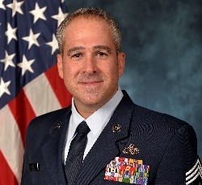
Chief Master Sergeant Kristopher K. Berg
Senior Enlisted Leader of the Alaskan NORAD Region, Alaskan Command
Command Chief Master Sergeant, Eleventh Air Force
Joint Base Elmendorf-Richardson, Alaska

Chief Master Sergeant Kristopher K. Berg is assigned as the Senior Enlisted Leader of the Alaskan NORAD Region, Alaskan Command, and the Command Chief Master Sergeant, Eleventh Air Force; Joint Base Elmendorf-Richardson, Alaska. He directly supports the missions of providing the Pacific and Northern Command combatant commanders, and Pacific Air Forces’ commander with ready forces and infrastructure for homeland defense, decisive force projection, and defense support to civil authorities, when requested. He facilitates mission requirements and advises the commander on matters of force utilization, morale, and welfare of the Soldiers, Airmen, Sailors, Marines, and Coast Guardsmen and their families assigned throughout the Alaska Joint Operations Area, Hawaii and Guam.
Chief Berg grew up in Decatur, Illinois and entered the United States Air Force in February 1994. He has served in multiple aircraft maintenance positions throughout his career at squadron, group, numbered Air Force, and major command levels. He has deployed in support of Operations Allied Force, Iraqi Freedom and Enduring Freedom. Prior to his current position, Chief Berg served as the Command Chief, Air Force Expeditionary Center, Joint Base McGuire-Dix-Lakehurst, N.J. He assumed his current position in October 2020.

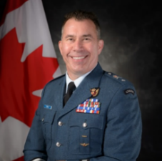
Brigadier General Sean “Kiwi” Boyle OMM, MSC, MSM, CD
Deputy Director General, Continental Defence Policy
National Defence Headquarters, Department of National Defence
Ottawa, Ontario, Canada
sean.boyle@forces.gc.ca

BGen Boyle serves in the Continental Defence Policy directorate of Canada’s Defence Policy organization. He is responsible for supporting and overseeing the work of two key policy teams: Domains and Technology Policy (Arctic, Climate Change, Space, Cyber, AI, Quantum, and more) and NORAD Policy (Continental Defence & NORAD Modernization). BGen Boyle’s operational background includes Ballistic Missile Warning Officer, Space Orbital Analyst and Air Battle Manager (over 2,000 hrs flown on NATO and French E-3s and dozens of combat sorties during Kosovo). He has been privileged with five Command tours at Squadron, Air Detachment and Wing levels, including deployed operations in Qatar, Afghanistan and Kuwait. Key staff appointments prior to Policy Group include CAOC Director at 1st Canadian Air Division and Director of Fighter Capability Requirements on the RCAF’s Air Staff. A qualified military parachutist & rescue SCUBA diver, BGen Boyle is a graduate of CF Staff School, Fighter Weapons Instructors Course, Joint Command and Staff College, and USAF Air War College. Initially graduating from the Royal Military College of Canada with a BSc, he also holds a Masters degree of Information Systems Management and a Master’s degree of Defence Studies. He is currently a PhD candidate of Organizational Leadership and Information Systems Technology.

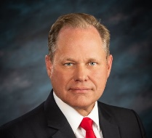
Honorable Dave Bronson
Mayor
Municipality of Anchorage
Anchorage, Alaska

Anchorage, Alaska is home to Dave Bronson after a two year corporate commitment that turned into a love for Alaska lasting 29 years and counting! Born June 26, 1958 in Superior, Wisconsin, Dave earned his Bachelor of Science Degree in Agricultural Economics from the University of Wisconsin. After graduation, he was an Active Duty Air Force Pilot from 1981 to 1990, USAF Reserves Plans Officer from 1992 to 1993, and an Alaska ANG Maintenance Officer and Pilot from 1993 to 2005 while balancing a commercial airline pilot career from 1990 to 2020.
While flying military aircraft, he met and married Debra. They have been married for 35 years and have raised two children, Katie and Zach. His love for The Last Frontier includes land, air, and water as he enjoys exploring Alaska while hunting, fishing, and flying to remote areas.

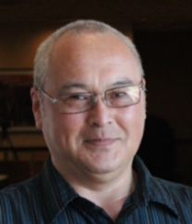
Honorable Harry K. Brower, Jr.
Mayor of the North Slope Borough,
Utqiagvik (formally Barrow), Alaska

Harry K. Brower, Jr. has been serving the people of the North Slope Borough as Mayor for the past several years. He is a lifelong resident of the northern most community, Barrow, Alaska. Harry is a whaling captain and is a proud provider to his wife and five children, numerous relatives, and members of his community as a very active subsistence hunter. Harry has served previously as the Deputy Director of the Borough's Wildlife Management Department, Chairman of the Alaska Eskimo Whaling Commission, and Chairman of the Subsistence Subcommittee of the Arctic Waterways Safety Committee. In addition to his work on behalf of bowhead whale and other marine mammal subsistence hunters, Harry has been heavily involved in the design and implementation of efforts to document levels of subsistence harvest in the North Slope villages and land use by subsistence hunters. Harry also serves as a member in numerous committees and councils in Alaska and has involved himself internationally, representing the lnupiat people at meetings of the International Whaling Commission. He has participated in numerous public hearings and public meetings regarding potential impacts of industrial activity to wildlife and subsistence hunting activities. Harry is a regular guest presenter on subsistence-related topics at various local, state, and national conferences.


Dr Elizabeth Buchanan
Head of Research
Royal Australian Navy
Sea Power Centre, Australia

Dr Elizabeth Buchanan is Head of Research for the Royal Australian Navy. Dr Buchanan is an Australian polar geopolitics expert, and co-founder and co-director of Project 6633 at the West Point’s Modern War Institute. She was formally lecturer of strategic studies for the Defence and Strategic Studies Course (06/07) at the Australian War College. Dr Buchanan holds a PhD in Russian Arctic strategy from the Australian National University (ANU). Elizabeth was formally a Maritime Fellow at the NATO Defense College. She has published two books: Russian Energy Strategy Under Putin with ANU Press and Red Arctic: Russian Strategy Under Putin with The Brookings Institution Press. Dr Buchanan is a polar contributor for Janes Intelligence and has published widely on polar geopolitics most recently with the NATO Defence College, International Affairs, The National Interest, War on the Rocks, RUSI, Foreign Policy and Foreign Affairs. Elizabeth has been a Visiting Scholar with The Brookings Institution and has work experience in the global oil sector. She Tweets @BuchananLiz.

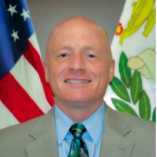
Lt. Col. U.S. Army (Ret.) Michael C. Burgoyne
Professor
Asia-Pacific Center for Security Studies
Honolulu, Hawaii

Michael Burgoyne, US Army Lieutenant Colonel (retired), joined the Daniel K. Inouye Asia-Pacific Center for Security Studies in July 2016 as a Military Professor. His areas of focus at DKI APCSS are Security Cooperation, International Affairs, Taiwan, and China. His experience in the Asia-Pacific includes most recently serving as the Army Programs Officer at the American Institute in Taiwan (AIT), Taipei. Before that, he was a university student in Beijing, an intern in the Defense Attaché Office in the U.S. Embassy in Beijing, and an intern in the Liaison Affairs Section at AIT. Professor Burgoyne started his military career as a Field Artillery Officer in 1997. He served in numerous leadership and staff positions in the 1st Infantry Division, III Corps, and the 1st Cavalry Division.

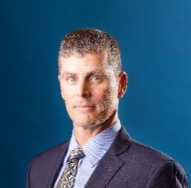
COL (Ret) Jay Chapman
Director, Government Programs
Iridium Communications Inc.
McLean, Virginia
jay.chapman@iridium.com

Colonel Jay Chapman, United States Army (Retired) serves as the Director of Government Programs at Iridium Communications Inc., the only satellite communications company that offers truly global voice and data coverage. In this role, he is responsible for business development and partner engagement for the Department of Defense business sector, with an emphasis on increasing applications and the use of Iridium-enabled products and services by the U.S. Federal Government. Jay has a proven track record working across the breadth of the DoD formations to include expeditionary and enterprise IT workforces and myriad command and staff positions with the intelligence and communications communities and Army and Joint Staffs.

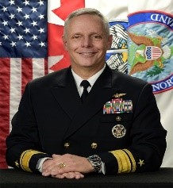
RADM Daniel “Undra” Cheever
Director of Strategy, Policy & Plans
NORAD and USNORTHCOM
Colorado Springs, CO
Daniel.l.cheever.mil@mail.mil

RADM Daniel “Undra” Cheever, USN serves as the Director of Strategy, Policy and Plans, North American Aerospace Defense Command and United States Northern Command. He is responsible for North American Aerospace Defense Command strategy, policy, plans and requirements development for the safeguarding of the United States and Canada via assigned missions of aerospace warning, aerospace control, and maritime warning. For U.S. Northern Command, he leads development of strategy, policy, deliberate plans, and security cooperation with Canada, Mexico and The Bahamas, to accomplish primary missions of homeland defense and support to civil authorities.


Mrs. Veronica N. Clark
Chief of Policy & Programs
Alaskan Command
Joint-Base Elmendorf-Richardson
veronica.clark.2@us.af.mil

Veronica N. Clark Department of the United States Air Force Civilian, serves as the Chief of Policy and Programs for Alaskan Command located at Joint-Base Elmendorf-Richardson. She also serves as the Command’s Women, Peace, and Security Gender Focal Point. Mrs. Clark is responsible for synchronizing the Command’s Arctic program through capability advocacy, theater security cooperation, partnerships, and knowledge management; contributing to the development of communication synchronization strategy; ensuring the accurate representation of capability requirements in Alaskan NORAD Region and Alaskan Command inputs to the planning, programming, and budgeting system. She recently completed a graduate program with Cornell University regarding Women in Leadership, and currently holds a Master of Business Administration degree, a Bachelor of Arts degree in Business Administration, an Associates of Applied Science in Communication, and an Associates of Arts degree in Liberal Arts. She is married, has two children, two fur babies, and enjoys the great outdoors.

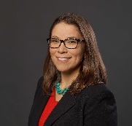
Liz Qaulluq Cravalho
Vice President of Lands
NANA
Kotzebue, AK
liz.cravalho@nana.com

Liz Qaulluq Cravalho is NANA’s vice president of lands, responsible for providing strategic leadership and management for programs that focus on the environmental protection and enhancement of NANA lands for use by shareholders and communities. NANA is an Alaska Native Corporation located in the Arctic whose mission is to improve the quality of life for shareholders by maximizing economic growth, protecting, and enhancing our lands and promoting healthy communities. A global corporation, NANA’s $1.7B in revenue is earned through responsible resource development and supporting federal customers in meeting their mission. A NANA shareholder from Kotzebue, Liz has also worked with external affairs, representing, and advancing NANA’s interests in various areas of policy, including Arctic opportunities and Indigenous representation. President Joe Biden appointed Liz to serve as an industry member on the U.S. Arctic Research Commission, an independent federal agency that advises the president and Congress on domestic and international Arctic research. Previously, Liz served on the Alaska Arctic Policy Commission to provide recommendations to the Alaska Legislature on Arctic policy matters. Liz holds a Master of Science in organization development from American University and a bachelor’s degree in history from Colorado College.

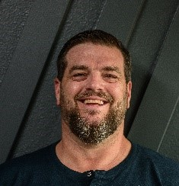
Joey Crum
President & CEO
Northern Industrial Training, LLC (NIT)
Palmer, Alaska
Joey.crum@nitalaska.com

Joey Crum serves as the President & CEO of Northern Industrial Training, LLC (NIT). NIT is Alaska’s premier vocational skills training organization and a workforce development specialist, ground by Five Anchors: Respect, Professionalism, Integrity, Consistency and the Will to Succeed. NIT serves Alaskans from and in every corner of the state, recognizing that a highly trained, critical thinking workforce is in demand and paramount to our economy, security and future. As a lifelong Alaskan, Joey has personally been to hundreds of communities around Alaska and works with organizations from Ketchikan to St. Paul, to Kaktovik and everywhere in between. Joey also serves on the Civilian Advisory Board for Alaskan Command and in the Civil Leaders’ Program for the Air and Space Forces.

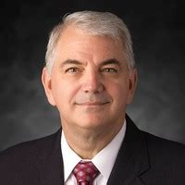
Col (Ret) Paul Curlett,
IRSA (Integrated Remote Sensing of the Arctic),
The Boeing Company, St. Louis, Missouri

Col (Ret) Paul Curlett, USAF, supports the Boeing Integrated Remote Sensing of the Arctic and a number of other efforts enabling Communications Networking and Mission Systems Senior Sales Lead, Boeing Phantom Works at the Boeing Company in St. Louis.

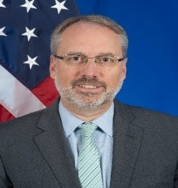
Coordinator Jim DeHart
U.S. Coordinator for the Arctic Region
U.S. Department of State
Washington, D.C.

Jim DeHart was appointed U.S. Coordinator for the Arctic Region in 2020. He is a career member of the Senior Foreign Service with the rank of Minister Counselor. DeHart has held a wide range of positions throughout his career, including Assistant Chief of Mission at the U.S. Embassy in Kabul (2018-2019), Director of the U.S. Provincial Reconstruction Team in Panjshir (2009-2010), Director for Central Asia on the National Security Council Staff (2007-2008), and Deputy Chief of Mission in Oslo, Norway (2015–2018). Prior to his appointment as Coordinator, DeHart led U.S. negotiations of status of forces, defense cooperation, and burden-sharing agreements worldwide. Coordinator DeHart was raised in a Foreign Service family in Australia, Hong Kong, the Dominican Republic, Mexico, Washington, DC, and Central Oregon. He holds a B.A. from Gonzaga University in Spokane, Washington, and a Master’s in International Affairs from The Elliott School at George Washington University.

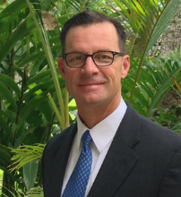
Maj Gen, US Air Force (Ret) Mark Dillon
Director, Business Development
Aurora Flight Sciences
Manassas, VA
dillon.mark@aurora.aero
Mobile: (703) 659-3898

Maj Gen Mark "Marshal" Dillon, US Air Force (Ret), serves as Director of Business Development, Aurora Flight Sciences, a Boeing Company. Mark brings 33 years of military and international experience to the Aurora team and in his final Air Force assignment served as the Deputy Commander, Pacific Air Forces and Deputy Joint Force Air Component Commander for US INDO-PACOM, Joint Base Pearl Harbor-Hickam, Hawaii. Aurora specializes in creating advanced aircraft through the development of versatile and intuitive autonomous systems, in addition to advanced composite manufacturing. Headquartered in Manassas Virginia, Aurora has facilities in Mississippi, West Virginia, Massachusetts, and Luzern, Switzerland.

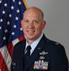
Col Christopher “Demo” Domitrovich
119th Wing, Vice Commander
North Dakota Air National Guard
Fargo, North Dakota
christopher.domitrovich@us.af.mil

Col Christopher “Demo” Domitrovich, North Dakota Air National Guard serves as the 119th Wing Vice Commander, where he is second in command of nearly 1,200 Airmen who train and execute world-class MQ-9 precision attack and reconnaissance, kinetic and non-kinetic intelligence target production and expeditionary combat support. Col Domitrovich has experience in a variety of operational assignments, contingency operations and headquarters staff assignments. Additionally, Col Domitrovich is a command pilot with over 3,000 hours in the F-16, C-21A, MQ-1B, and MQ-9. He is a 2015 graduate of the National Intelligence University, Washington, D.C., and a 2020 graduate of the U.S. Naval War College, Newport, R.I.

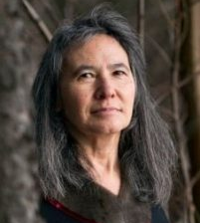
Dr. Dalee Sambo Dorough,
International Chair,
Inuit Circumpolar Council
Alaska, Anchorage Alaska

Dr. Dalee Sambo Dorough (Inuit-Alaska) is the elected International Chair of the Inuit Circumpolar Council, a non-governmental organization that represents approximately 180,000 Inuit from the Russian Far East, Alaska, Canada and Greenland. She holds a Ph.D. from University of British Columbia, Faculty of Law (2002) and a Master of Arts in Law & Diplomacy from The Fletcher School at Tufts University (1991). She is affiliated with the University of Alaska Anchorage where she served as an Assistant Professor of International Relations within the Department of Political Science from 2008-2018; former Chairperson [2014] and Expert Member of the UN Permanent Forum on Indigenous Issues (2010-2016); and co-Chair of the International Law Association (ILA) Committee on Implementation of the Rights of Indigenous Peoples. Research interests relate to Indigenous peoples and Arctic issues. Her recent publications include “The Rights, Interests and Role of the Arctic Council Permanent Participants” R. Beckman, T. Henriksen, K. Kraabel, E.J. Molenaar and J.A. Roach (eds) Governance of Arctic Shipping. Balancing Rights and Interests of Arctic States and User States (Brill: 2017); and “Indigenous Peoples’ Right to Cultural Heritage”, co-authored with Siegfried Wiessner, University of Miami School of Law, chapter on Oxford Handbook on Cultural Heritage Law, A. Vrdoljak, ed, forthcoming. Dr. Dorough lives in Anchorage, AK with her husband, Luke Dorough (Waccamaw Siouan) and their 23-year old daughter, Hannah, who is embarking upon a Master’s degree in the UK.

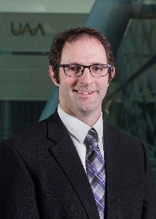
Dr. Aaron Dotson
Vice Chancellor for Research,
University of Alaska Anchorage
Anchorage, Alaska

Dr. Aaron Dotson serves as the Vice Chancellor for Research at the University of Alaska Anchorage, (UAA) and as a Professor of Civil Engineering for the College of Engineering at UAA. He also serves as the Principal Investigator for the Arctic Domain Awareness Center at UAA, a Department of Homeland Security Center of Excellence in Maritime Research.

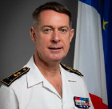
Rear Admiral Hilaire Ducellier
Deputy Chief of Staff Plans
JFC Norfolk

Rear Admiral Hilaire Ducellier joined the French Naval Academy in 1984 and is now the Deputy Chief of Staff Plans for JFC Norfolk. Prior to this, he served as the executive coordinator for international affairs in the Joint Staff in Paris and was delegated Authority for National Support Elements in NATO. Rear Admiral Ducellier’s command assignments include the Anti Submarine Destroyer “Tourville”, the Maritime Operation Center in Brest, the aviso “Lieutenenant de vaisseau Lavallée”, and the training ship “Lion”. Trained as a Combat Information Centre Officer, he has also held positions as JFC Lisbon Situation Center Branch Head, the Training and Experimentation Division Head for JALLC in Monsanto, and operations councilor in the French Delegation to NATO in Bruxelles. Rear Admiral Ducellier has served in Operations Balbuzard and Sharp Guard in the Adriatic, Restore Hope in Somalia, Resolute Behaviour, and Enduring Freedom. He has conducted numerous operational missions in the Atlantic and has served in the High North. Rear Admiral Ducellier earned a Master in Naval Engineering, is graduated from the French Staff College in Paris, and took part in the Postgraduate Course in European Studies of the Ecole Nationale d’Adminsitration in 2018.

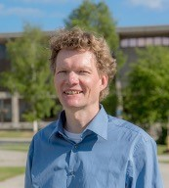
Dr. Hajo Eicken
Director
International Arctic Research Center
University of Alaska Fairbanks
Fairbanks, AK, USA
heicken@alaska.edu
Hajo Eicken is Professor of Geophysics and Director of the International Arctic Research Center at the University of Alaska Fairbanks. His research focuses on sea ice geophysics, Arctic coastal processes, and their importance for human activities and ecosystems. In Alaska he has helped lead efforts to advance collaborative research with Indigenous knowledge holders and to enhance use of scientific data by Arctic communities and government agencies. Other collaborative efforts include his involvement in helping launch the Arctic Sea Ice Outlook and Sea Ice Prediction Network, his co-leadership of the Arctic Observing Summit, service as Chair of a National Academies Standing Committee on Offshore Science and Assessment, and member of the Science Advisory Board for the 3rd Arctic Science Ministerial.

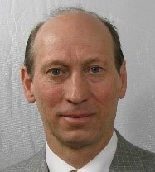
Maj Gen (ret) Mats Engman
Distinguished Military Fellow
ISDP – Institute for Security and Development Policy
Stockholm, Sweden
mengman@isdp.eu

Maj Gen Mats Engman has more than forty years of active military service. He has a long carrier in military Intelligence, strategy and plans and policy. Working at Plans and Policy he was responsible for operational planning, force planning, NORDEFCO, EU, Nato and Arctic policies. Before retiring at the end of 2017, his last assignment was as Head of the Swedish Delegation to the Neutral Nations Supervisory Commission, in South Korea. After retirement, he joined ISDP – as a Distinguished Military Fellow where his work focuses on military strategy and developments in East Asia, particular China, Taiwan and the security situation on the Korean peninsula.

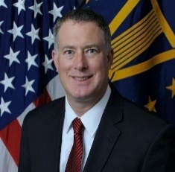
Mr. Dan Erikson
Deputy Assistant Secretary for Defense, Western Hemisphere Affairs
Office of the Secretary Defense for Policy
Pentagon, Washington D.C.

Daniel P. Erikson is the Deputy Assistant Secretary of Defense for the Western Hemisphere at the U.S. Department of Defense. In this capacity, he serves in the Office of the Secretary of Defense and is responsible for U.S. defense and security policy for the thirty-four nation region that encompasses Canada, Mexico, Central America, the Caribbean, and South America. Mr. Erikson served as the Western Hemisphere policy lead for the Biden-Harris Transition. He previously served in the White House as special advisor to then-Vice President Joe Biden, where he covered foreign affairs and national security issues in the Americas. Prior to the White House, he served in the U.S. Department of State as senior advisor for Congressional and Inter-Governmental Affairs and senior advisor for Western Hemisphere Affairs. In 2017, he received the State Department’s Superior Honor Award for his diplomatic contributions to U.S.-Latin American relations, including the advancement of bipartisan policies to support security and development in Central America and Colombia. In addition to his U.S. government experience, Mr. Erikson has held senior positions in the private sector, think-tanks, and academia. He has published widely on a range of topics in international and Latin American and Caribbean affairs and testified before the U.S. Congress. Mr. Erikson earned his Master’s in Public Policy at the Harvard Kennedy School and a B.A. in International Relations from Brown University. He was a Fulbright Scholar in Mexico and is a member of the Council on Foreign Relations. He lives with his wife and two daughters in Washington, D.C.

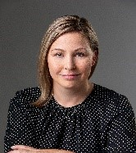
Dr. Heather Exner-Pirot
Senior Policy Analyst
Macdonald Laurier Institute
exnerpirot@gmail.com

Heather Exner-Pirot is a Senior Policy Analyst at the Macdonald Laurier Institute, a Principal Consultant at Morris Interactive, and a Global Fellow at the Wilson Centre’s Polar Institute in Washington D.C. She also serves as the Research and Communications Advisor for the Indigenous Resource Network. Heather sits on the boards of the Canadian Rural Revitalization Foundation, the Saskatchewan Indigenous Economic Development Network, and The Arctic Institute. She is also the Managing Editor of the Arctic Yearbook and the former Chair of the Canadian Northern Studies Trust. She earned her PhD in Political Science from the University of Calgary.

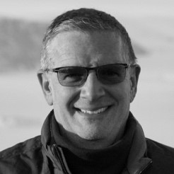
Dr. John Farrell
Executive Director
US Arctic Research Commission
Arlington, VA
jfarrell@arctic.gov

Since 2006, Dr. John Farrell has served as the Executive Director of the U.S. Arctic Research Commission, an independent federal agency that advises the White House and Congress on Arctic research. He obtained a PhD and ScM in geological sciences from Brown University and a BA in geology from Franklin and Marshall College. He was an NSF-funded postdoctoral fellow at Brown and an NSERC-funded senior research associate at the University of British Columbia. He previously served as the Associate Dean of Research and Administration at the University of Rhode Island Graduate School of Oceanography. Before that, he was the director of the international Ocean Drilling Program that involved over 20 nations and had an annual budget of approximately $65M/yr. He helped organize and conduct the first successful international scientific ocean drilling expedition to the high Arctic in 2004. He participated in Arctic Ocean mapping and scientific research expeditions aboard the icebreaker US Coast Guard Cutter Healy in 2012 to the high Arctic, and in 2021 through the Northwest Passage. In 2019 he participated in a scientific expedition to previously uncharted fjords in northern Greenland. In 2019 he was awarded the Presidential Rank Award of Distinguished Executive. Additional biographical information here.

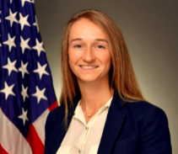
Ms. Iris Ferguson
Deputy Assistant Secretary for Defense, Arctic & Global Resilience
Office of the Secretary Defense for Policy
Pentagon, Washington D.C.

Ms. Iris Ferguson, was sworn in on 18 April 2022 as the first Deputy Assistant Secretary for Defense, Office of the Secretary Defense for Policy, Pentagon, Washington D.C. Before this, Iris served as a Senior Advisor to the U.S. Air Force, responsible for advising the Deputy Chief of Staff for Strategy on Arctic strategy, operations, and international partnerships.
Prior, she served as Special Assistant to the Assistant Secretary of the Air Force for Installations, Environment, & Energy, focusing on energy security, resilience and sustainability policies. Ms. Ferguson also served for the Department of Commerce’s International Trade Administration, structuring and implementing the first federal investment promotion program, Select USA; and as national security and foreign policy legislative aide for then Senator Joseph Biden on the Senate Foreign Relations Committee. She holds an MA from Johns Hopkins SAIS and BA from the University of Arkansas.

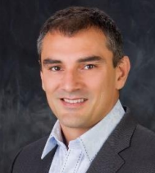
Mr. Craig L. Fleener
Deputy Advisor, Arctic Security Affairs
Ted Stevens Center for Arctic Security Studies
Anchorage, Alaska
craig.fleener@us.af.mil

Mr. Craig Fleener serves as the Deputy Advisor and Chief of Staff, Arctic Security Affairs, Defense Security Cooperation Agency, at the Ted Stevens Center for Arctic Security Studies. In addition to his duties at the Stevens Center, Craig has a 35-year military career and currently serves in a traditional guardsman role with the Alaska Air National Guard and is currently a Lt Colonel. His tribal duties include serving in elected office. Craig has actively participated in the Arctic Council as a representative Gwich'in Council International, one of the six internationally recognized Arctic indigenous groups. He has served for three different governors of Alaska as the Director of the Division of Subsistence, Deputy Commissioner of the Department of Fish and Game, and as an appointed cabinet member responsible for Arctic Policy and Director of State and Federal Relations where he also served as third in line of succession for governor.

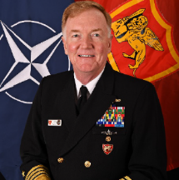
James G. “Jamie” Foggo, Admiral, USN (Ret)
Dean, Center for Maritime Strategy
Navy League of the United States

James G. “Jamie” Foggo is currently serving as the dean for the Center for Maritime Strategy at the Navy League of the United States. A retired four-star admiral, Foggo is a 1981 graduate of the U.S. Naval Academy. He is also an Olmsted Scholar and Moreau Scholar, earning a Master of Public Administration at Harvard University and a Diplome d’Etudes Approfondies in defense and strategic studies from the University of Strasbourg, France. Throughout his career, Foggo has been a champion of the Navy as an extended arm of diplomacy. He maintained close relationships with the U.S. ambassadors in his area of responsibility from Europe to Africa and into the Middle East. He sponsored numerous regional ambassadors conferences at his headquarters in Naples to address security challenges in the Balkans, Mediterranean and the Black Sea regions. Throughout 2021, he taught a seminar at the Foreign Service Institute on civil-military relations for rising foreign service officers. In November 2021, Foggo was named to the American Academy of Diplomacy as one of a handful of retired flag officers who serve alongside more than 200 retired ambassadors with the common goal of enhancing American diplomacy around the globe.

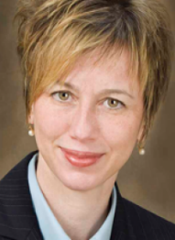
Dr. Kathryn Friedman, Emeritus Professor,
University at Buffalo,
Global Fellow, Woodrow Wilson International Center for Scholars (Canada Institute).
University at Buffalo, Buffalo, New York.

Kathryn Bryk Friedman is a Research Associate Professor of Law & Planning at the University at Buffalo and a Global Fellow at the Woodrow Wilson International Center for Scholars (Canada Institute). A multi-disciplinary scholar and legal practitioner with focus on CA-US law and policy, Friedman is a recognized expert on the CA-US relationship in both Canada and the United States. Her research and teaching focus on binational regional economies; water law and policy (Great Lakes and New York State); NAFTA; labor mobility; and border security issues. Friedman communicates strategic insights using various media, including radio, newspapers, peer-reviewed journals, and policy papers; presents findings publicly at conferences, workshops, and forums; and briefs public officials at policy workshops held regionally and nationally. A former Fulbright Fellow, Friedman was selected to participate in the AILA International Fellowship at the Center for Strategic and International Studies (CSIS) in Washington, DC in spring 2018 – the flagship CSIS leadership program to equip aspiring global leaders to be effective and ethical changemakers. She serves as a Member of the Buffalo Niagara Partnership Can Am Business Council; a Fellow of the Foreign Policy Association; and Board Member of the Alliance for the Great Lakes (Chicago). Prior to her work in higher education, Friedman served as a Confidential Law Clerk to the Hon. Richard C. Wesley and Hon. Eugene F. Pigott and was an associate in the cross-border practice group at a large New York law firm.
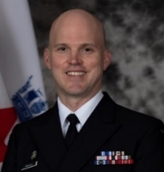
Captain (Navy) Jacob French
Commander Adjoint
Joint Task Force (North)
Yellowknife, Northwest Territories
Jacob.French@forces.gc.ca

Captain(N) Jacob French joined the Canadian Forces in 1994 in Saint John, NB as a Naval Warfare Officer. As a junior officer he conducted multiple deployments as a Bridge Watchkeeper / Navigating Officer and Operations Room Officer. His most recent sea posting was as Commanding Officer HMCS Regina in 2018 – 2019, which included an Indo Asia Pacific and Northern Arabian Sea deployment under Operation ARTEMIS and PROJECTION, as Commander of the Maritime Task Force with HMCS REGINA and MV Asterix. This deployment also included a contribution to Operation NEON, support to UNSCR sanctions on North Korea in the East China Sea. Prior to this he was the RCN Project Director Interim AOR (MV ASTERIX), which included successful sea trials of MV ASTERIX in early 2018. He holds a Masters of Defence Studies from Australia National University as a graduate of the Australia Command and Staff Course in 2013. He was promoted to his current rank of Captain (N) in July 2020, and he is currently appointed as Deputy Commander Joint Task Force North in Yellowknife, NT.

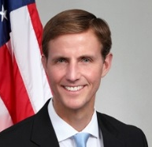
The Honorable Tim Gallaudet, PhD, Rear Admiral, U.S. Navy (ret)
CEO, Ocean STL Consulting, LLC
Host of the American Blue Economy Podcast
North Beach, Maryland
OceanSTLeader@gmail.com

Rear Admiral Tim Gallaudet, PhD, US Navy (ret) serves on the Board of Directors for Force Blue, is a strategic advisor for Lynker Technologies, tomorrow.io, iXblue, Sofar Ocean, precursor SPC, Xona Space Systems, Circles, and the American Security Project, and contributes as a research affiliate with Harvard University’s Galileo Project. Gallaudet is a member of the Ocean Studies Board in the National Academies of Science, Engineering and Medicine, an associate editor for the of Artificial Intelligence for the Earth Systems (AIES) journal of the American Meteorological Society (AMS), and a member of the Marine Technology Society (MTS), a fellow at The Explorer’s Club, and a distinguished graduate of the University of California, San Diego. From 2017-2021, Gallaudet served as the Assistant Secretary of Commerce for Oceans and Atmosphere/Deputy NOAA Administrator, leading NOAA’s Blue Economy activities to advance marine transportation, sustainable seafood production, ocean exploration and mapping, marine tourism and recreation, and coastal resilience. Prior to NOAA, Gallaudet served for 32 years in the US Navy, completing his career as the Oceanographer of the Navy, Navigator of the Navy, and Director of the Navy’s Task Force Climate Change and Task Force Ocean. Gallaudet has a Bachelor’s degree from the U.S. Naval Academy and Master’s and Doctoral degrees from Scripps Institution of Oceanography.

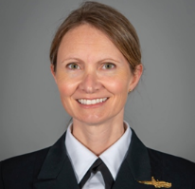
CDR Rachael Gosnell
United States Navy

Commander Rachael Gosnell is a Foreign Area Officer and Strategist in the U.S. Navy. She served at sea onboard USS SHILOH (CG-67), USS HARRY S. TRUMAN (CVN-75), and USS STOCKDALE (DDG 106). Ashore assignments included OPNAV 513 Strategy & Policy, Political Science Department at U.S. Naval Academy, and as Speechwriter for the 30th Chief of Naval Operations, Admiral Greenert. While at U.S. Naval Forces Europe/Africa and Joint Force Command – Naples, she served as Speechwriter and in the Commander’s Action Group for Admiral Foggo and Admiral Burke. Gosnell is a doctoral candidate in International Security and Economic Policy at the University of Maryland, with a focus on U.S. Arctic strategy and the implications for Arctic security dilemma dynamics. She earned a Masters in International Security Studies from Georgetown University through the Navy’s Politico-Military Masters Program. She also holds a Masters of Engineering Management from Old Dominion University and Bachelors of Science in Political Science from the U.S. Naval Academy. She serves as the Program Director of the Marshall Center’s European Security Seminar – North, and has published and presented extensively on Arctic security.

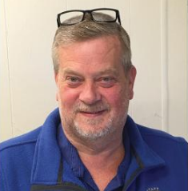
Honorable John K. Handeland
Mayor, Nome, Alaska

The Honorable John K. Handeland serves as the Mayor of Nome Alaska. Nome’s residents elected Mr. Handeland in October of 2020.

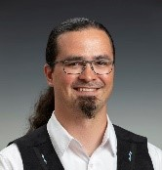
Mr. Nagruk Harcharek
Operations Manager
UIC Construction
Anchorage, Alaska
Nagruk.Harcharek@UICCS.com

Nagruk Harcharek began his career with UIC Science as a project manager and was promoted to General Manager by 2016. In 2018 he was promoted again to Director of Barrow Operations and Vice President of Lands where he managed a 25-million-dollar commercial portfolio and all land holdings for Ukpeaġvik Inupiat Corporation. He recently moved his family to Anchorage, AK and took the position of Operations Manager for UIC Construction and serves on the UIC Board of Directors as the Vice President of the Corporation. During the last 8 years, 6 of them were spent on the North Pacific Research Board providing advice and guidance for Arctic research projects. He is also a member of the Polar Research Board. In his spare time, Mr. Harcharek enjoys flying, subsistence hunting and fishing with his wife and children.


Ms. Victoria Herrmann,
White House Fellow assigned to HQ U.S. Coast Guard,
Washington D.C.
On leave of absence as President and Managing Director of The Arctic Institute,
Washington, D.C.
Victoria Herrmann is a White House Fellow, serving with HQ U.S. Coast Guard in Washington, D.C. She is on a leave of absence as President and Managing Director of The Arctic Institute. In addition to managing the Institute and Board of Directors, her research and writing focus on climate change, community adaptation, human development, and resource economies, with a particular focus on Arctic oil and gas. Herrmann is a Gates Scholar at the Scott Polar Research Institute at the University of Cambridge, where she is pursuing a PhD in Political Geography of the Arctic. In 2016, she is traveling across the United States for a National Geographic funded book on climate change stories, America’s Eroding Edges. Victoria previously worked at the Carnegie Endowment for International Peace’s Energy and Climate Program as a Junior Fellow. She was awarded a Eureka! Prize from the Baker Institute for Entrepreneurship in 2012 and a Fulbright Scholarship to Canada to pursue Arctic research in 2013. She is the author of Arctic Melt: Turning Resource Extraction into Human Development (2015) and has been published in many peer-review journals, including the Polar Law Yearbook, Polar Record, and Polar Geography. Her expert opinion has appeared on CNN, BBC, and NPR among others. Victoria holds a Master’s degree from the Norman Paterson School of International Affairs at Carleton University in Ottawa and Bachelor’s degree in International Relations and Art History from Lehigh University in Pennsylvania.

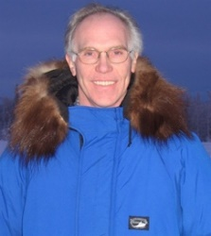
Dr. Larry Hinzman
Assistant Director for Polar Science and the Executive Director of IARPC
Office of Science and Technology Policy
Washington DC
Larry.D.Hinzman@ostp.eop.gov

Larry Hinzman is the Assistant Director of Polar Sciences in the White House Office of Science and Technology Policy and the Executive Director of the Interagency Arctic Research Policy Committee. He recently served as the Vice Chancellor for Research and as a Professor of Civil and Environmental Engineering at the University of Alaska Fairbanks. Hinzman served as the Director of the UAF International Arctic Research Center from 2007 to 2015. Professor Hinzman's primary research interests involve permafrost hydrology. He conducted hydrological and meteorological field studies in the Alaskan Arctic continuously for over 35 years while frequently collaborating on complementary research in the Russian and Canadian Arctic. He has served as a member of the U.S. Polar Research Board and as the U.S. delegate and president of the International Arctic Science Committee. He is strongly committed to facilitating national and international partnerships to advance our understanding of the Arctic and Antarctic systems.

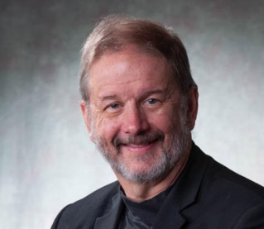
Dr. Rob Huebert
Associate Professor of Political Science,
University of Calgary
Calgary, Alberta

Dr. Rob Huebert (Associate Professor of Political Science, University of Calgary), a leading Canadian commentator on Arctic security and defense issues in media, academic, and policy circles, will continue to monitor and analyze Arctic defense and international security trends, with a particular focus on strategic policy and military capabilities and how developments impact on Canadian Arctic security. His areas of research interests include international relations, strategic studies, the Law of the Sea, maritime affairs, Canadian foreign and defense policy, and circumpolar relations. His books include Canada and the Changing Arctic: Sovereignty, Security and Stewardship (co-authored with Franklyn Griffiths and Lackenbauer, 2011) and (Re)Conceptualizing Arctic Security: Selected Articles from the Journal of Military and Security Studies (co-edited with Lackenbauer and Ryan Dean, 2017).

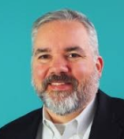
Richard Holmquist
Director
HawkEye360

Richard Holmquist is HawkEye 360’s sales executive for the Americas. Richard has more than 20 years of experience in the commercial satellite remote sensing industry. His work with HawkEye 360’s RF geolocation and analytics products follows an extensive career in maritime domain awareness, vessel tracking, commercial marine fisheries, and oceanographic data systems. Prior to working in the remote sensing industry, Richard was an Alaska Domestic Fisheries Observer and earned his MS degree from the Virginia Institute of Marine Science, College of William and Mary.

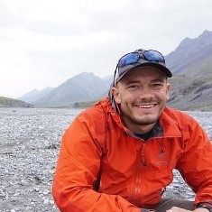
Mr. Taylor Holshouser,
Managing Director, Alaska Ocean Cluster, & Bering Sea Fishermen’s Association
Anchorage, Alaska
taylor@alaskaoceancluster.com

Taylor Drew Holshouser is a managing director at the Alaska Ocean Cluster, a startup accelerator dedicated to advancing technological innovations that benefit Alaska’s marine industries, coastal communities, and ocean ecosystems. He is also a research fellow at the Wilson Center’s Polar Institute and a former member of the Arctic Economic Council’s Blue Economy and Infrastructure and Investment Working Groups. Prior to joining the Alaska Ocean Cluster, Taylor worked as an associate for a local family office and as an analyst for the Central Intelligence Agency. He was born and raised in Alaska, is a graduate of Yale, and enjoys fly-fishing and collecting books about the economic history of the Arctic in his spare time.

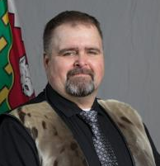
Jackie Jacobson
Member
Legislative Assembly of the NWT for Nunakput

Jackie Jacobson was elected to the 19th Northwest Territories Legislative Assembly as the Member representing Nunakput. Mr. Jacobson was first elected as Member for Nunakput in the 16th Legislative Assembly in 2007 and was re-elected into the 17th Legislative Assembly in 2011. Mr. Jacobson was the first Inuvialuit Speaker of the Northwest Territories Legislative Assembly from 2011-2015. Mr. Jacobson has been an active member of Tuktoyaktuk over the last 25 years, serving on the Hamlet Council as the Mayor for two terms and as a Hamlet Councilor for two terms. He served as the secretary/treasurer of the Tuktoyaktuk Community Corporation for eight years, as a community recreation board member for three years, and as the Chair of the Tuktoyaktuk Housing board for four years. In addition, Mr. Jacobson served for six years as both Member of the Board and as the Chair of the Inuvialuit Development Corporation, and Chair of the Human Resources Board with Norterra. Mr. Jacobson is a 23-year member of the Canadian Rangers, now bearing the rank of Sergeant. He also served in the Junior Rangers and as a member of the local search and rescue team. Mr. Jacobson has been an active volunteer member of the Tuktoyaktuk Fire Department for the past 25 years. Mr. Jacobson’s work experience includes five years as a Tuktoyaktuk community constable and six years with TransCanada Pipelines as a construction inspector.

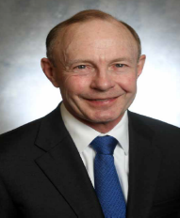
Charles H. Jacoby, Jr. Maj.General (US Army Retired)
Senior Strategic Advisor
Quintillion

Charles H. Jacoby, Jr. is a retired US Army General with over 37 years of experience leading military, government, and international organizations. Prior to retiring from the military, he was the first Army officer to command the North American Aerospace Defense Command (NORAD), as well as the United States Northern Command – where he led the 1,800-person bi-national joint headquarters integrating 35 federal, state, and non-governmental organizations. Other joint assignments included Deputy Director, Joint Staff J-5 Western Hemisphere, Deputy Commander CJTF-76 Afghanistan, Director Joint Staff J-5. General Jacoby commanded at all levels to include Rifle Company and Parachute Infantry Battalion in the 82nd Airborne Division, Joint Task Force Bravo in Honduras, Ist US Corps, Multi-National Corps Iraq. General Jacoby holds a B.S from the United States Military Academy at West Point; a M.A. from the University of Michigan; a M.S. in Military Arts & Science from the School of Advanced Military Studies; and a M.A. from the National War College. After retirement he acts as the Senior Strategic advisor for Quintillion as well as several other organizations. Jacoby sits on the Boards of the El Pomar Foundation and the Institute for Defense.

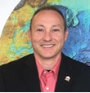
Mr. Shannon Jenkins
Senior Arctic Advisor
Office Arctic Policy, USCG
HQ US Coast Guard
Washington, D.C.

Shannon Jenkins serves as head of the Arctic Policy Office at U.S. Coast Guard Headquarters. His responsibilities include coordinating all Arctic related cross-directorate actions, harmonizing Coast Guard program office and field efforts, leading Arctic policy and strategy development, and tracking Arctic implementation-plan actions and progress. Shannon provides expert assistance and advice on Arctic topics, and he advances Coast Guard and National interests through engagements at public, private, and international forums. His mandate is to promote Coast Guard interests in the Arctic region to include safe, secure, and environmentally responsible maritime activity. Prior to his role as Senior Arctic Policy Advisor, Shannon Jenkins served as a Program Manager within the Coast Guard’s Research, Development, Test, & Evaluation Program Office. He managed the Arctic and the Environmental & Waterways research areas. His duties included identifying research needs and priorities for these areas, maintaining oversight of project execution and resource management, and addressing internal and external leadership queries. Shannon was a member of the Integrated Product Teams that developed the Coast Guard High Latitude Mission Analysis Report as well as the Polar Icebreaker Mission Needs Statement, Concept of Operations, and Preliminary Operational Requirements Document. He was also one of the authors of the joint DHS/DOD Arctic Capabilities Assessment Working Group White Paper to identify shared Arctic capability gaps.
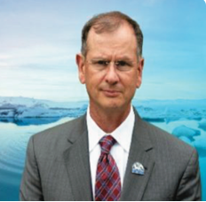
Maj Gen (Ret) Randy “Church” Kee
Senior Advisor, Arctic Security Affairs
Ted Stevens Center for Arctic Security Studies
Anchorage, Alaska
randy.kee.1@us.af.mil

Maj Gen Randy "Church" Kee, USAF (ret) is leading the Ted Stevens Center for Arctic Security Studies, Department of Defense’s newest regional center located in Anchorage Alaska. In 2020, the President of the U.S. appointed Kee as a Commissioner to the U.S. Arctic Research Commission, and from January 2016 to August 2021 he was the Executive Director of the Arctic Domain Awareness Center, a U.S. Department of Homeland Security Center of Excellence, hosted by the University of Alaska. Kee also serves a Global Fellow of the Woodrow Wilson Polar Institute; Network member of North American and Arctic Defense and Security Network; designated U.S. lead for a technology working group for the International Cooperative Engagement Program for Polar Research; and Co-chair of the Alaska Civilian Armed Services Team, an advisory Board to the Alaska Governor. During his 30-year military career, Kee led at squadron, group, wing, and Air Operations Center levels. General Kee’s staff assignments include U.S. Transportation Command, Headquarters USAF, and U.S. Joint Staff in both Operations plus Strategic Plans and Policy Directorates. He culminated his military service as Director of Strategy, Policy, Planning & Capabilities for U.S. European Command in Stuttgart, Germany. His USAF Biography is available at: www.af.mil/AboutUs/Biographies/Display/tabid/225/Article/108465/major-general-randya-kee.aspx.

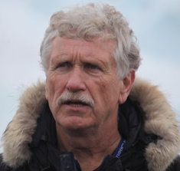
Brendan P. Kelly
Executive Director
International Arctic Research Center
University of Alaska Fairbanks
Fairbanks, Alaska

Brendan P. Kelly is the Executive Director of the Study of Environmental Arctic Change and Professor of Marine Biology at the International Arctic Research Center, University of Alaska Fairbanks. He also serves as a Senior Fellow with the Center for the Blue Economy at the Middlebury Institute of International Studies at Monterey. A marine ecologist with a focus on sea ice environments, he has participated in and led collaborative research in the North Pacific Ocean, Arctic Ocean, Sea of Okhotsk, Baltic Sea, and Antarctica. He has served as Deputy Director for Arctic Sciences, National Science Foundation; Assistant Director for Polar Science in the White House Office of Science and Technology Policy; and as a science adviser to indigenous organizations in Alaska. Currently, he serves on the National Academy of Sciences’ Polar Research Board and as a member of the Positions Statement Committee of the American Geophysical Union. Dr. Kelly received degrees in Biology from the University of California Santa Cruz (B.A.), the University of Alaska Fairbanks (M.S.), and Purdue University (Ph.D.).

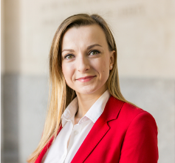
Katarina Kertysova
Policy Fellow at the European Leadership Network (ELN)
Global Fellow at the Polar and Kennan Institutes of the Woodrow Wilson Center
NATO 2030 Young Leader
London, UK
katarinak@europeanleadershipnetwork.org

Katarina Kertysova is a Policy Fellow at the European Leadership Network (ELN) in London and a Global Fellow at the Polar and Kennan Institutes of the Woodrow Wilson Centre. Her work focuses on conventional arms control, Russia-West and Russia-NATO relations, Arctic security, and the climate-security nexus. During her tenure of Wilson Center’s George F. Kennan Fellowship in 2020, Katarina’s research focused on Russian military build-up in the Arctic and ways in which regional and international organizations with a security mandate can help mitigate military security risks and prevent an inadvertent escalation in the region. Katarina holds a degree in International Relations and French from the University of St Andrews, after which she pursued security studies at Sciences Po Paris, and the Moscow State Institute of International Relations (MGIMO). Her previous research experience includes work conducted for the UNDP, the Carnegie Moscow Centre, the GLOBSEC Policy Institute, the Clingendael International Energy Programme (CIEP), and The Hague Centre for Strategic Studies (HCSS). As a member of the NATO 2030 Young Leaders Group, Katarina contributed to the NATO 2030 Reflection Process in the area of climate security. She continues to advance NATO’s climate agenda in various advisory roles (advising the Slovak MoD, for example), as well as through external events and publications.

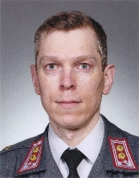
Lieutenant Colonel Lasse-Tapani Ketola
Assistant Defense, Military, Naval and Air Attaché to the U.S. and Canada
Embassy of Finland
Washington, D.C.
lasse-tapani.ketola@formin.fi

LTC Lasse-Tapani Ketola, Finnish Defense Forces serves as the Assistant Defense, Military, Naval and Air Attaché to the United States and Canada at Defense Attaché Office of Embassy of Finland in Washington D.C. The office is responsible for performing representational functions on behalf of the Finnish Defense Forces leadership. In addition, it supports and promotes cooperation with the United States and Canada. LTC Ketola was commissioned in 2002 from the Military Academy, Finnish National Defense University and has served in various positions in Finnish Defense Forces.

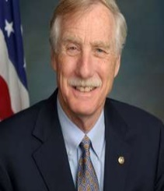
Honorable Senator Angus King (I-Maine)

On January 3, 2013, Angus S. King, Jr. was sworn in as Maine’s first Independent United States Senator. Senator King joins a long line of independent leaders from the State of Maine. He is a steadfast believer in the need for greater bipartisan dialogue and relationship building among legislators. Senator King began his career as a staff attorney for Pine Tree Legal Assistance in Skowhegan. In 1972, he served as chief counsel to U.S. Senate Subcommittee on Alcoholism and Narcotics in the office of former Maine Senator William Hathaway. In 1975, he returned to Maine to practice with Smith, Loyd and King in Brunswick. In 1983, he was appointed Vice President of Swift River/Hafslund Company, an alternative energy development company working on hydro and biomass projects in Maine and New England. Six years later, he founded Northeast Energy Management, Inc., a developer of large-scale energy conservation initiatives at commercial and industrial facilities in Maine. In 1994, Senator King was elected Maine's 71st Governor. During his two terms in the Blaine House, he focused on economic development and job creation, and also achieved significant reforms in education, mental health services, land conservation, environmental protection, and the delivery of state services. He was re-elected in 1998 by one of the largest margins in Maine’s history. Senator King was born in Alexandria, VA in 1944. He graduated from Dartmouth College in 1966 and from University of Virginia Law School in 1969. Senator King is married to Mary Herman and has four sons, Angus III, Duncan, James, and Ben, one daughter, Molly, and five grandchildren. He lives in Brunswick.

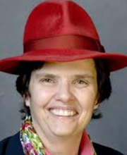
Dr. Nancy Kinner
University Professor, Civil and Environmental Engineering
Coastal Response Research Center
The University of New Hampshire

Nancy Kinner's main areas of research interest are oil spill response and restoration, bioremediation of contaminated subsurface environments and more generally, environmental microbiology. She is a member of the Environmental Research Group (ERG) at UNH and has conducted research on wastewater biofilm microbiology, the role of protists in subsurface and sea ice contaminant degradation, and petroleum and chlorinated solvent bioremediation. A professor of Civil and Environmental Engineering, Kinner has been co-director of the Coastal Response Research Center, a partnership between UNH and the National Oceanic and Atmospheric Administration (NOAA), since 2004. The center brings together the resources of a research-oriented university and the field expertise of NOAA’s Office of Response and Restoration to conduct and oversee basic and applied research, conduct outreach, and encourage strategic partnerships in spill response, assessment and restoration.

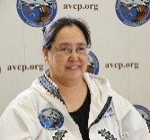
Vivian Anginran Korthuis
Chief Executive Officer
Association of Village Council Presidents
Bethel, Alaska
VKorthuis@avcp.org

Vivian Anginran Korthuis became the Chief Executive Officer of AVCP in October of 2016. In her first year as CEO, Vivian launched an organization-wide Quality Improvement Process (QIP), to improve service delivery at the expressed request of the AVCP Executive Board and tribal delegates of the Yukon-Kuskokwim Delta (YK Delta). The Association of Village Council Presidents is the regional native non-profit tribal consortium serving 56 Tribes on the Yukon Kuskokwim Delta in Western Alaska. Prior to her appointment, Vivian served AVCP for 20 years in several capacities including Vice President of Programs. Before that, she worked in a leadership capacity at the Yukon-Kuskokwim Health Corporation and as a school teacher. Vivian has been a lifelong advocate for the Y-K Delta region and has more than 35 years’ experience working to improve education, health care, and social services delivery within the region. Currently, Vivian serves on several boards including the Inuit Circumpolar Council Executive Board, the Alaska Federation of Natives Board of Directors, and the Yuut Elintuarviat Board of Directors. Vivian was born in Bethel and raised in Emmonak, Alaska. She graduated from Mount Edgecumbe High School in Sitka, holds a bachelor’s degree from Dartmouth College, and a master’s in education from the University of Alaska Fairbanks.

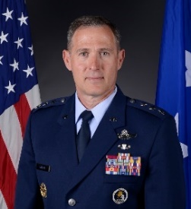
Lt. Gen. David A. Krumm, USAF
Commander,
Alaskan Command, United States Northern Command
Eleventh Air Force, Pacific Air Forces
Alaska Region, North American Aerospace Defense Command
Joint Base Elmendorf-Richardson, Alaska

Lt. Gen. David A. Krumm is the Commander, Alaskan Command, United States Northern Command; Commander, Eleventh Air Force, Pacific Air Forces; and Commander, North American Aerospace Defense Command Region, North American Aerospace Defense Command, Joint Base Elmendorf-Richardson, Alaska. He is the senior military officer in Alaska, responsible for the integration of all military activities in the Alaskan joint operations area, synchronizing the activities of more than 21,000 active-duty and reserve forces from all services. As Commander of the Alaskan Region of the North American Aerospace Defense Command, General Krumm directs operations to ensure effective surveillance, monitoring and defense of the region’s airspace. He is also responsible for the planning and execution of all homeland defense operations within the area of responsibility, including security and civil support actions. General Krumm also commands Eleventh Air Force, overseeing the training and readiness of five wings and Air Force installations located in Alaska, Hawaii, and Guam. His USAF Bio is located at: https://www.af.mil/About-Us/Biographies/Display/Article/486910/david-a-krumm/

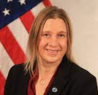
Dr. Kelly Kryc
Deputy Assistant Secretary for International Fisheries
Office of the Under Secretary for Oceans and Atmosphere National Oceanic and Atmospheric Administration
Washington, D.C.
Kelly.kryc@noaa.gov
Kelly Kryc, Ph.D., is the Deputy Assistant Secretary for International Fisheries at the National Oceanic and Atmospheric Administration. Dr. Kryc has extensive public sector, academic, non-profit, and legislative experience in energy and environment policy. Prior to joining NOAA in September 2021, she had most recently served as senior fellow for energy and environment at the Center for American Progress, and as director of ocean policy at the New England Aquarium in Boston. Previous positions also include those with the U.S. Senate Committee on Energy and Natural Resources, the U.S. State Department, The White House Office of Science and Technology Policy, and the U.S. Department of the Interior. She is also an adjunct faculty member of Georgetown University’s Science in Public Interest Program where she teaches science policy. Dr. Kryc received a Ph.D. in earth science from Boston University, an M.S. in oceanography from the Graduate School of Oceanography at the University of Rhode Island, and a B.A., in geology and marine science from Middlebury College in Vermont.

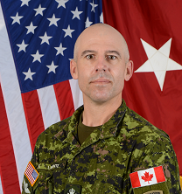
Brigadier General Louis Lapointe
Deputy Commanding General of Operations
United States Army Alaska
Joint Base Elmendorf-Richardson, Alaska
louis.m.lapointe2.fm@army.mil

Brigadier General Louis Lapointe serves as the Deputy Commanding General of Operations at United States Army Alaska. He joined the Canadian Forces in 1991 as an infantry officer at the Royal Military College of Canada Saint-Jean. He has held multiple staff appointments within the 5th Canadian Mechanized Brigade Group, the Canadian Army Headquarters and the Strategic Joint Staff. Brigadier General Lapointe has deployed numerous times in support of United Nations security missions in Haiti and Afghanistan and on various domestic operations in Canada. He completed the United States Army Ranger Course in 2003 and was awarded the Ralph Puckett and William O. Darby Awards. He holds a Bachelor’s Degree in Business Administration and Master in Defense Studies from the Royal Military College of Canada. Prior to his appointment with United States Army Alaska, Brigadier General Lapointe served as the Commander of the 4th Canadian Division Support Group.


Dr. Scott Lindsey
Regional Director, NOAA’s National Weather Service
Alaska Region
Anchorage, Alaska
scott.lindsey@noaa.gov

Scott Lindsey serves as the Regional Director of the National Weather Service Alaska Region. His team consists of professional physical scientists and support staff at Weather Forecast Offices in Anchorage, Fairbanks and Juneau, the Alaska-Pacific River Forecast Center, the Alaska Aviation Weather Unit, the Center Weather Service Unit in Anchorage, and the National Tsunami Warning Center in Palmer, Alaska as well as 11 remote Weather Service Offices. These experts support and provide weather, water and climate services for an area of land, marine and offshore area equivalent to about 47% of the total area of the lower 48 states. Dr. Lindsey previously led the Alaska-Pacific River Forecast Center where his career in operational hydrology in Alaska began in 1994. He has worked tirelessly to advance our scientific understanding and capabilities in hydrology operations. The Alaska Region NWS continually strives to meet an updated and unparalleled mission statement - Provide weather, water and climate data, forecasts, warnings, and impact-based decision support services for the protection of life and property and enhancement of the national economy.

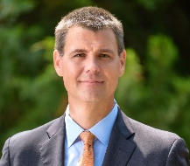
Bridge Littleton
Co-Founder and President
Hellen Systems
Middleburg VA

Bridge Littleton is the Co-Founder and President of Hellen Systems, a technology development company focused on the development and deployment of enhanced LORAN (eLORAN) as a resilient back up system to the Global Positioning System (GPS) being executed through a Public Private Partnership with the US Government. This 21st century project is focused on providing a resilient capability to every sector of our economy. GPS has been defined as a “single point of failure” by the Dept. of Homeland Security for critical infrastructure which our national economy depends on. Hellen System’s technology will protect us from this vulnerability. Prior to founding Hellen Systems, Bridge was the Vice President for Membership & Business Development for the Aerospace Industries Association (AIA), overseeing all membership activities, business development into new markets and the Supply Chain Management Council for the Association. Previously he severed as the Chief Contracts Officer for Exelis Inc. a large aerospace and defense contractor which was acquired by L3Harris in 2015. Bridge received his BS in History and Political Science at Radford University and his Juris Doctor from the University of Richmond School of Law, with one term of his law school career attending Kings College School of Law in Aberdeen Scotland. Bridge also currently serves as the Mayor of the Town of Middleburg, Virginia.

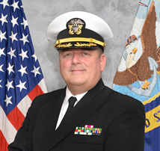
CDR Dan Lubin
Commanding Officer
ONR-RC Detachment 203 San Diego
San Diego, California
dan.lubin@navy.mil

CDR Dan Lubin serves with the Office of Naval Research Reserve Component where he supports ONR-Global on ICE-PPR as leader of Communications Sub-Working Group under the Situational Awareness Working Group. In his civilian career, CDR Lubin is a research physicist at UCSD Scripps Institution of Oceanography, where he works on meteorology and climatology of Earth's polar regions, on satellite remote sensing, and on astronomical observation of solar-type stars related to terrestrial climate variability. In 2015-16 CDR Lubin was the lead principal investigator for a year-long polar field campaign called the ARM West Antarctic Radiation Experiment (AWARE), which is the largest and most advanced deployment of atmospheric and climate science equipment ever sent to Antarctica. He brings his extensive high latitude fieldwork experience to his role with ICE-PPR. An Engineering Duty Officer in the Navy Reserve, CDR Lubin has held Commanding Officer tours with NAVSEA, NAVWAR and ONR-RC. CDR Lubin has a BA degree in Physics from Northwestern University, an MS in Astronomy and Astrophysics and an PhD in Geophysical Sciences from the University of Chicago, and an MA degree in National Security and Strategic Studies from the US Naval War College.

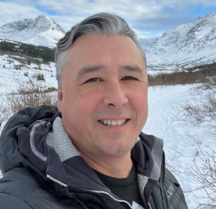
Mr. Steve MacLean
Managing Director
World Wildlife Fund US Arctic Program
Anchorage, Alaska
steve.maclean@wwfus.org

Mr. Steve MacLean is the managing director of the World Wildlife Fund US Arctic Program. Steve is the Managing Director of the US Arctic Program where he leads a dedicated team developing and implementing strategies to conserve Arctic ecosystems in Alaska for the benefit of the planet and people. Steve has worked in marine conservation, ecology, and management in Alaska for more than 20 years. He has worked in communities from southeast Alaska to the Aleutian Islands, through the Bering Sea and North Slope. He has first-hand experience living and working in remote Alaskan villages and with Alaska Native peoples.


Robert P. McCoy, PhD
Director, Geophysical Institute
University of Alaska Fairbanks
Fairbanks Alaska

Bob McCoy has been the Director of the Geophysical Institute (GI) since 2011. The GI is home to ~400 faculty, staff and students who do research in: Volcanology; Seismology; Snow, Ice and Permafrost; Atmospheric Science; Tectonics and Sedimentation; Remote Sensing; and Space Physics and Aeronomy. The GI is home to 9 operational facilities including the: Alaska Volcano Observatory; Alaska Earthquake Center; Alaska Satellite Facility; Poker Flat Research Range; Alaska Center for Unmanned Aircraft System Integration; Wilson Alaska Technical Center; Research Computing Services; Geographic Information Network for Alaska; and the High frequency Active Auroral Research Facility. In 2018 the GI became the newest DoD University Affiliated Research Center (UARC) for Geophysical Detection of Nuclear Proliferation. Prior to coming to Alaska, he worked for the Navy for 30 years in the Washington D.C. area; 15 years as a space scientist at the NRL and 15 years as a program officer at the ONR. During his last four years at ONR he was jointly appointed as the Technical Director of the Operationally Responsive Space (ORS) Office at Kirtland AFB. At NRL Bob was principal investigator for 23 sounding rocket, satellite and International Space Station experiments to study the upper atmosphere and ionosphere.

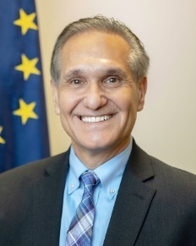
Lt. Governor Kevin Meyer
Office of the Governor
State of Alaska
Juneau, Alaska

Alaska Lieutenant Governor Kevin Meyer serves as the state’s Secretary of State and leads the state’s Division of Elections handling all state elections, citizen ballot initiatives, and referenda. In his short time as Lt. Governor, Kevin has been selected to numerous national committee positions including the Cybersecurity Committee, Elections Committee, and International Relations Committee for The National Association of Secretaries of State, the Policy Resolution Committee for The National Lt. Governors Association, Vice-Chair for the Aerospace States Association, and the Executive Committee for The Pacific Northwest Economic Region. The Lt. Governor represents the Governor’s Office as Ex-Officio Board member for the Alaska Travel Industry Association and the Alaska Seafood Marketing Institute. Kevin has had a long career in public service. In 1993, he was elected to the Anchorage Assembly, then in 2000 to the Alaska State House of Representatives, and in 2008 to the Alaska State Senate. He has held several key leadership positions in the legislature, including Co‐Chair of the House and Senate Finance Committees, Senate Majority Leader, Senate Rules Chair, and in 2015-2016 he was chosen by his colleagues to serve as President of the Senate.

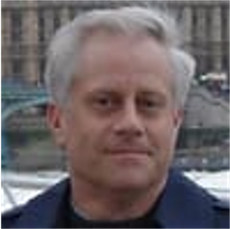
Mr. Sean Moon
Chief, Global Strategies, Office of Strategy, Policy, and Plans
U.S. Department of Homeland Security
Washington, District of Columbia, United States
sean.moon@hq.dhs.gov

Sean Moon is the Chief of Global Strategies in the U. S. Department of Homeland Security Office of Policy, Washington, D.C. Among other projects in his portfolio, he is the Policy lead for Arctic strategy development. Between 2011 and 2016, he served the Department as Director, Transportation and Cargo Policy and chaired the Asia-Pacific Economic Cooperation Sub-group for Maritime Security. A 1985 graduate of Willamette University in Salem, Oregon, he spent four years in the private sector before joining the U.S. Coast Guard in 1989. Over the course of a 20-year career, he specialized in port operations and emergency management, community engagement, commercial and passenger vessel and facility safety and security programs, waterways management programs, and oil/hazardous materials and natural disaster response operations.

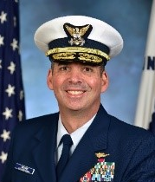
RADM Nathan Moore
Commander, 17th Coast Guard District
United States Coast Guard
Juneau, Alaska
Nathan.A.Moore@uscg.mil

Rear Admiral Moore assumed the duties of Commander, 17th Coast Guard District in April 2021. He is responsible for Coast Guard operations throughout Alaska, the North Pacific Ocean, the Arctic Ocean, and the Bering Sea. These operations include protecting life and property, ensuring marine safety, enforcing federal laws and treaties, protecting the marine environment, preserving living marine resources, and promoting national security. The Coast Guard’s forces in Alaska total more than 2,500 active duty, reserve, civilian and auxiliary personnel, who employ 15 cutters, 52 boats, and 17 aircraft. Headquartered in Juneau, the District Commander provides operationally ready maritime forces to Coast Guard and Department of Defense Commanders for Coast Guard, joint, and interagency operations both domestically and internationally.

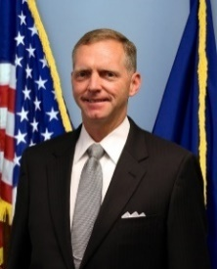
John D. Murphy
Chief Operating Officer
National Weather Service (NWS)
National Oceanic and Atmospheric Administration
United States Department of Commerce
Washington D.C.

John D. Murphy is the Chief Operating Officer (COO). He has overall responsibility for day-to-day mission execution units responsible for delivering NWS weather, water, climate, and space weather products, services, and information as well as the budgetary planning for 11 National Service Programs. Mr. Murphy came to the NWS after serving more than 29 years with the United States Air Force as a career meteorologist. He topped off his military weather career while serving as Commander of the Air Force Weather Agency where he managed more than 1,400 agency personnel located at 18 geographically-separated units worldwide. Just prior to joining NWS, Mr. Murphy served as the Deputy Foreign Policy Advisor to United States Strategic Command (USSTRATCOM). He was the primary interlocutor between the command, the U.S. State Department, and foreign governments on issues related to deterrence, space, and cyberspace.

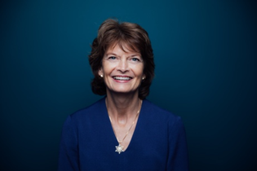
Honorable Senator Lisa Murkowski (R-Alaska)

Senator Lisa Murkowski is Alaska’s senior Senator, joining the Senate in 2002. She Chairs the Senate Energy and Natural Resources Committee and also serves on the Senate Appropriations Committee, where she is the Chairman of the Interior and Environment Subcommittee. Senator Murkowski is a member of the Senate Health, Education, Labor and Pensions Committee and also is a senior member of the Senate Indian Affairs Committee.

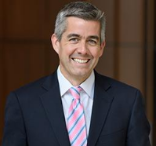
Commander, JAGC (Ret) Mark P. Nevitt
Associate Professor of Law
Syracuse University College of Law
Syracuse, New York

Mark P. Nevitt (@MarkNevitt) Commander, JAGC (ret.) is an Associate Professor of Law at Syracuse University College of Law. He was previously the Class of 1971 Distinguished Military Professor of Leadership & Law at the United States Naval Academy in Annapolis, Maryland and a Sharswood Fellow at the University of Pennsylvania Law School. Prior to law school, Prof. Nevitt served as a naval tactical jet aviator, accumulating 290 aircraft carrier arrested landings, 1,000 flight hours and was awarded the Air Medal. Originally from Rhode Island, Professor Nevitt received his J.D. and LL.M. with distinction from the Georgetown University Law Center. During law school, he served as a White House Military Social Aide and taught Street Law at Anacostia High School.

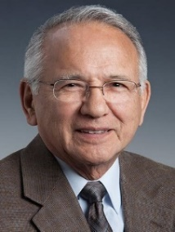
Mr. Emil Notti
Native American Hall of Fame
Inducted 2021

Mr. Emil Notti, Athabascan, was the first president of Alaska Federation of Natives, founded in 1966. Notti was a force behind the land claims movement and central to the negotiations that culminated in the Alaska Native Claims Settlement Act of 1971. The legislation authorized Alaska Natives to receive title to 44 million acres of public land in Alaska and a $962 million land claims settlement, further establishing village and regional Native corporations. He was instrumental in calling for a convening of Alaska Natives from every region of the state. An electronic and aeronautical engineer, he worked on the Minuteman Ballistic Missile and worked for the Federal Aviation Administration. Notti served under several Alaska governors as Deputy Commissioner of Health and Social Services, Commissioner of Community and Regional Affairs and Commissioner of Commerce, Community and Economic Development.

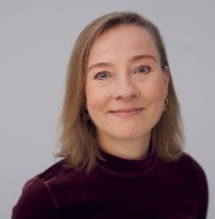
Liselotte Odgaard
Professor
Norwegian Institute for Defense Studies
Oslo, Norway

Liselotte Odgaard is a professor at the Norwegian Institute for Defense Studies and a non-resident senior fellow at Hudson Institute in Washington, D.C. Her work focuses on US–China–Europe relations, including NATO–China relations; Chinese foreign, security and defense policy; Indo-Pacific security, and the geopolitics of the Arctic region. Dr Odgaard has been a visiting scholar at institutions such as Harvard University, the Woodrow Wilson International Center for Scholars, and the Norwegian Nobel Institute. She is the author of numerous monographs, books, peer-reviewed articles, and research papers on Chinese and Asia-Pacific security, and she is a frequent commentator on these issues in the media. She regularly participates in policy dialogues such as the Arctic Circle Assembly in Iceland and the Xiangshan Forum in Beijing. She received her bachelor’s, master’s, and PhD in political science from Aarhus University in Denmark, as well as a master’s degree in international studies from the University of Warwick in the UK.

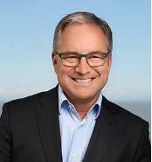
Sean Parnell
Chancellor, University of Alaska Anchorage

Former Alaska Governor Sean Parnell began his role as chancellor of the University of Alaska Anchorage on June 12, 2021, succeeding interim chancellor Bruce Schultz. Most recently an attorney in the Anchorage office of Holland & Hart LLP, Sean Parnell has 25 years in the active practice of law. He was elected to two terms in the Alaska House of Representatives, serving there from 1992 until 1996 when he was elected to the Alaska Senate (1996-2000). In 2006, he was elected Lieutenant Governor and served as Governor of Alaska from 2009 to 2014. Parnell graduated from East Anchorage High School in 1980, earned a bachelor's degree in business administration in 1984 from Pacific Lutheran University and a J.D. degree in 1987 from the University of Puget Sound School of Law (now known as Seattle University School of Law).

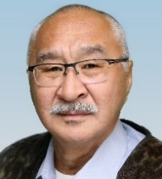
Hugh Patkotak Sr.
President & CEO
Olgoonik Corporation
Wainwright, Alaska

Hugh Patkotak Sr. is President & CEO of Olgoonik Corporation, an Alaska Native corporation where all of its Iñupiaq shareholders are proud to have their family ties link them with America’s Arctic coast community of Wainwright, Alaska. Born and raised in Wainwright, a subsistence community on the Chukchi Sea, Patkotak Sr. has served on the Corporation’s Board of Directors in various positions for more than a decade. During this tenure, he has been actively involved in fulfilling Olgoonik’s mission and instrumental in guiding the organization’s continued growth. He is also an active member of the Wainwright Steering Committee and serves as a board member for the nonprofit VOICE of the Arctic Iñupiat. Prior to assuming his executive leadership position with Olgoonik, Patkotak Sr. was an accomplished professional pilot for more than three decades. For nearly 20 years, he served in the North Slope Borough’s Search and Rescue Flight Division where he conducted airborne response in one of the world’s most challenging environments. Flying continues to be his enduring hobby and passion. For more information about Olgoonik Corporation or its executives, please email communications@olgoonik.com or call Jamie Gonzales at 907-375-4734.

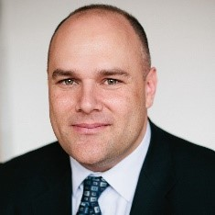
William Patrowicz, Jr.
CEO
Kaiser Global Development Group LLC
New York & Reykjavik
bill@kaiserglobal.us

Mr. Patrowicz is the CEO of Kaiser Global, a development firm dedicated to raising capital and developing infrastructure projects for energy, space, and the environment. Kaiser’s first effort is a $382M project in Iceland called the Reykjavik Institute, a computational laboratory with supercomputing, artificial intelligence, machine learning, and quantum computing resources. Patrowicz is further developing a $3B portfolio of green energy and space exploration projects.
Prior to Kaiser, Patrowicz developed effective technology programs for security and safety in over ten nations and has expertise in constructing public-private partnerships in multi-lateral settings. He is a former US Army officer and a graduate of the University of Wisconsin-Madison.

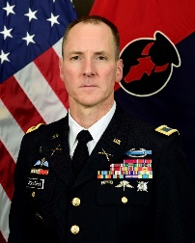
COL Simon L. Schaefer
Director of Plans and Policy (J5)
Minnesota National Guard
St. Paul, Minnesota

Colonel Simon Schaefer assumed duties as the Commander, 2^{d} Brigade (IBCT), 34th Infantry Division, Iowa National Guard, in October 2021. He also works full time (T-32 AGR) for the MN National Guard as the J5 Director of Plans and Policy. Colonel Schaefer began his military career in 1991 as an enlisted Soldier in the 75th Ranger Regiment. He has over 31 years of military service with operational tours to Somalia, Afghanistan, and Kuwait. Key assignments include BN S-3 Air Operations Officer; ROTC Assistant Professor of Military Science; BN Executive Officer; J33 Current Operations Chief; Executive Officer, Armor Brigade Combat Team; J1, Army Division Chief; G3 and Chief of Staff for the 34th ID; Joint Chief of Staff for the MNNG. Colonel Schaefer has a Bachelor’s degree in Zoology from North Dakota State University, a Master’s degree in Public Safety Executive Leadership from Saint Cloud State University, and a Master’s degree in Strategic Studies from the U.S. Army War College. His military education includes U.S. Army Ranger Course, Air Defense Officer Basic Course, Infantry Captains Career Course, Command and General Staff Officer Course, U.S. Army War College and the Executive Joint Domestic Operations Course.

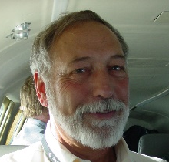
Dr. John F. Payne Senior Scientist
Michigan Tech Research Institute
Ann Arbor, Michigan
jfpayne@mtu.edu

Dr. John F. Payne, PhD, is a Senior Scientist with Michigan Tech Research Institute (MTRI), Ann Arbor, Michigan. MTRI is considered a development site for DARPA and DoD, especially in the use of remote sensing addressing technically difficult issues. Dr. Payne is responsible for the implementation of the North Slope Science Initiative and served as its Executive Director for a decade. Dr. Payne has also served as the U.S. co-lead (along with the Kingdom of Denmark) to the Arctic Council, Conservation of Arctic Flora and Fauna initiative developing status for terrestrial, fresh water and ocean biodiversity. He is past president of the Arctic Research Consortium of the U.S.

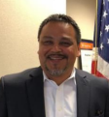
Mr. Eugene Peltola, Jr.
Regional Director
Bureau of Indian Affairs, Alaska Region
U.S. Department of Interior

Mr. Eugene Peltola, Jr. Regional Director, Bureau of Indian Affairs, Alaska Region, U.S. Department of Interior. Regional Director Peltola was selected as the Regional Director for the Bureau of Indian Affairs (BIA) in Alaska in 2018. Prior to this, he was at the U.S. Fish and Wildlife Service (USFWS) as the Federal Subsistence Management Program lead, Regional Director Peltola was responsible for coordinating and implementing subsistence management on all federal lands in Alaska on behalf of the Bureau of Indian Affairs, the Bureau of Land Management, the National Park Service, the USFWS, and the U.S. Forest Service. While he has worked in both the public and private sectors since 1984, Peltola’s 34-year federal career has been with the USFWS in Alaska, where he worked at 3 National Wildlife Refuges including as a zone supervisor for Refuge Law Enforcement and Refuge Manager for the Yukon Delta National Wildlife Refuge. Peltola has served in local government, on corporate boards, and owned and operated two businesses. From October 2010 to September 2012, he served as vice-mayor and council member for the city of Bethel, Alaska. While serving the city of Bethel, he sat on the boards of three Alaska Native village corporation entities: Bethel Solutions, LLC, a holding company of an Alaska Native Claims Settlement Act (ANCSA)-established village corporation specializing in commercial real estate construction Bethel Services, Inc., a subsidiary of an ANCSA-established corporation specializing in government contracting and Bethel Native Corporation, the village corporation for the community of Bethel.

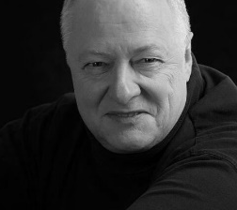
Mr. Tony Penikett
Former Premier of Yukon Territories
White Horse, Yukon, Canada

Tony Penikett spent 25 years in public life, including two years at the Canadian House of Commons as Chief of Staff to federal New Democratic Party Leader Ed Broadbent; five terms in the Yukon Legislative Assembly; and two terms as Premier of Canada’s Yukon Territory. His government negotiated settlements of Yukon First Nation land claims; passed pioneering legislation in the areas of education, health, language; and organised Yukon 2000, a unique bottom-up economic planning process. After serving as Premier of the Yukon, Penikett acted as Senior Aboriginal Policy Advisor for the Premier of Saskatchewan (1995-97) and Deputy Minister for Negotiations, and later Labour, for the Government of British Columbia (1997-2001). He is the author of three books, Breaking Trail: A Northern Political Journey (Victoria, BC: Trafford, 2004); Reconciliation: First Nations Treaty Making in British Columbia(Vancouver, BC: Douglas & McIntyre, 2006) and Hunting the Northern Character (Vancouver, BC: UBC Press, 2017), and two films, The Mad Trapper (BBC TV/Time Life Films) and La Patrouille Perdue (ORTF France). As a mediator and negotiator, Penikett has worked on devolution in the Northwest Territories, Nunavut and Yukon. He has lectured on the history of aboriginal treaty negotiations at Simon Fraser University, Queen’s University and the University of Washington. In 2013, Penikett became Fulbright Visiting Research Chair in Arctic Studies at the Henry M. Jackson School of International Studies at the University of Washington. In September 2014, Simon Fraser University’s Public Policy School appointed him visiting professor, and he now serves as Senior Associate at the Morris J Wosk Centre for Dialogue there. Penikett serves as a Mentor for the Walter & Duncan Gordon Foundation’s Jane Glassco Northern Fellows, Trudeau Mentor at The Pierre Elliott Trudeau Foundation and member of the Advisory Board at Polar Research and Policy Initiative.

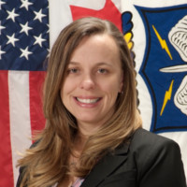
Ms. Tiffani Phillips
Security Cooperation Integration Deputy and Gender Advisor
USNORTHCOM

Ms. Tiffani Phillips is the Security Cooperation Integration Deputy and Gender Advisor for USNORTHCOM. She is responsible for the policy, planning, assessment, monitoring, and evaluation of Security Cooperation with Canada, Mexico, and The Bahamas and the implementation of Women, Peace, and Security across the USNORTHCOM enterprise. Ms. Phillips grew up in Niagara Falls, NY. She served in the Air Force in a variety of intelligence roles, including as a cryptologic linguist; Command Briefer and Ambassador for the Air Force Intelligence, Surveillance, and Reconnaissance Agency; and as a senior analyst supporting interrogation operations. Ms. Phillips became a civil servant in 2011 and continues to be key to the success of USNORTHCOM’s security cooperation, first as a policy and plans analyst and Commander’s speechwriter, then as the Canada Desk Officer, and in her current position. Most recently, Ms. Phillips oversaw the provision of gender advisory support for the relocation and resettlement of Afghan evacuees during Operation Allies Welcome – the first time that the Department has ever deployed this capability during an operation.

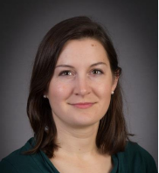
Dr. Rebecca Pincus
Assistant Professor
Strategic and Operational Research Department
U.S. Naval War College
Newport, Rhode Island
Rebecca.Pincus@usnwc.edu

Rebecca Pincus is Assistant Professor in the Strategic and Operational Research Department (SORD) in the Center for Naval Warfare Studies at the US Naval War College, and a member of the Institute for Future Warfare Studies within SORD. She previously served as primary investigator (PI) at the US Coast Guard's Center for Arctic Study and Policy, located at the US Coast Guard Academy.

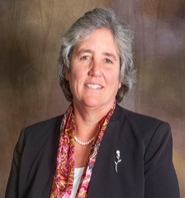
Ms. Pat Pitney
President
University of Alaska
Fairbanks, Alaska

The University of Alaska Board of Regents appointed Pat Pitney as the university system’s 17th president on Feb. 25, 2022. She served as interim president since Aug.1, 2020. Previously Pitney served as the state’s Director of the Division of Legislative Finance. She was the former Vice Chancellor of Administration, University of Alaska Fairbanks and worked at UA Statewide for 17 years. In all, Pitney spent 23 years with the University of Alaska before leaving to serve as the State Budget Director in the administration of former Governor Bill Walker.

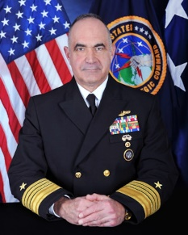
Admiral Charles “Chas” Richard, USN
Commander, U.S. Strategic Command,
Offutt Air Force Base, Nebraska,
U.S Department of Defense

Admiral Charles Richard is a native of Decatur, Alabama and graduated with honors from the University of Alabama in 1982. He earned master's degrees with honors from the Catholic University of America and the Naval War College. His most recent assignment was Commander, Submarine Forces in Norfolk, Virginia. Other flag assignments include Deputy Commander, U.S. Strategic Command, Director of Undersea Warfare (OPNAV N97) at the Pentagon, Deputy Commander of Joint Functional Component Command for Global Strike at U.S. Strategic Command, and command of Submarine Group 10 in Kings Bay, Georgia. His operational assignments include command of USS Parche (SSN 683) as well as Submarine NR-1, then the U.S. Navy's only nuclear-powered, deep-submergence submarine. He also served aboard USS Portsmouth (SSN 707), USS Asheville (SSN 758), and USS Scranton (SSN 756).
Admiral Richard's staff assignments include service as the executive assistant and naval aide to the Under Secretary of the Navy; chief of staff, Submarine Force Atlantic; and command of Submarine Squadron (SUBRON) 17 in Bangor, Washington. Other staff assignments include director of resources on the staff of the Under Secretary of Defense (Policy); squadron engineer on the staff of SUBRON-8 and duty on the Deputy Chief of Naval Operations (Submarine Warfare) staff. He has also served as a member of Chief of Naval Operations' Strategic Studies Group XXVIII, studying the integration of unmanned systems into naval force structure. Admiral Richard assumed his current duties in November 2019. As Commander, U.S. Strategic Command, he is responsible for one of 11 Unified Commands under the Department of Defense. USSTRATCOM is responsible for the global command and control of U.S. strategic forces to meet decisive national security objectives, providing a broad range of strategic capabilities and options for the President and Secretary of Defense.

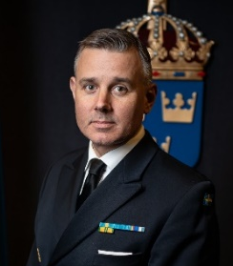
Colonel (RSwMC) Henrik Rosén
Naval and Assistant Defense Attaché
Embassy of Sweden
Washington DC
henrik.rosen@gov.se

Colonel Henrik Rosén serves as Naval Attaché at the Embassy of Sweden in Washington DC where he mainly works with strengthening the bilateral relation with U.S. Navy and U.S. Marine Corps as well as the fellow Naval Attachés to Sweden’s international partners. As Naval Attaché Colonel Rosén also follow the U.S. Department of Defense strategies and activities in Indo-Pacific region and the Arctic. Colonel Rosén background includes operational positions withing the Royal Swedish Navy/Marine Corps, lastly as Head of the Operational Department in the Navy Staff, but also various joint positions in the Defense Staff. Colonel Rosén experience also include regular training deployments in cold weather environment as well as to multinational operations in Africa/Mali.

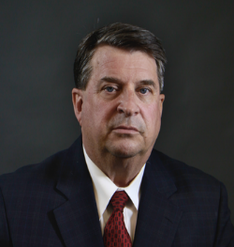
Mr. Mark Rosen
Senior Vice President and General Counsel
Center for Naval Analysis
Washington, D.C.

Mark Rosen is an expert in maritime law and policy, maritime arms control, the Arctic and regulation of the global commons, international law and treaties, the law of armed conflict and homeland security. Rosen's recent work includes analyses of conflicting maritime claims in the South China Sea, East China Sea, Bay of Bengal, the Arctic and the Gulf of Guinea. He is also conducting research on governance gaps that create vulnerabilities in space, cyberspace and the Arctic; effective insurgency suppression models that could be used in connection with operations in Afghanistan; an examination of U.S. options to reduce carbon emissions and dependence on foreign oil in anticipation of new international climate mandates; and the Navy's role in maritime law enforcement. Rosen is a retired Navy captain who served with the Navy Judge Advocate General's Corps as an international law attorney and military planner. He holds an LL.M. in International and Oceans Law from the University Of Virginia and both a B.A. and J.D. from the University of Georgia.

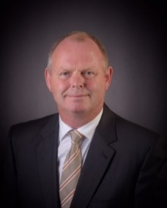
Rear Admiral (Ret) Lars Saunes
Royal Norwegian Navy
CNO Distinguished international fellow
Professor US Naval War College
Newport, Rhode Island

Rear Admiral Lars Saunes serves as Professor, CNO Distinguished International fellow at the U.S. Naval War college. As Chief of the Royal Norwegian Navy from 2014 to 2017, the Navy changed course towards high readiness and a renewed aim on warfighting skills. To meet Norwegian maritime security challenges in northern region of Europe and in the Arctic, he transformed the Norwegian Maritime Doctrine for Naval operations; «In operation or preparing for operation” and strengthened the allied team on the Northern flank of NATO. During his 37 years of military career, he has held the highest positions in submarine service, naval operations and Coast Guard operations. He has operational experience from NATO-, National HQs and Norwegian High Command/Joint Staff. He has held flag position as Commandant of the Norwegian Coast Guard and Chief of Royal Norwegian Navy. He retired as Chief of the Royal Norwegian Navy August 2017 and returned to the U.S. Naval War College where he graduated in 2004. His role as professor and CNO distinguished fellow includes co-leading The Newport Arctic Scholar Initiative, teaching and lecturing strategy and leadership, mentoring students and facilitate international cooperation and friendship.

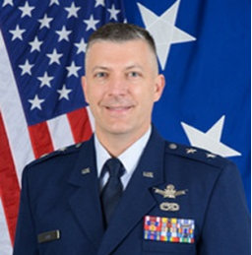
Maj Gen Torrence W. Saxe
Adjutant General, Alaska National Guard
Commissioner, Alaska Department of Military and Veterans Affairs

Maj Gen Torrence W. Saxe is the Adjutant General, Alaska National Guard and the Commissioner, Alaska Department of Military and Veterans Affairs. As the adjutant general, he is the senior military advisor to the governor of Alaska and commander of the Alaska National Guard, responsible for overseeing the training and readiness of 3,900 Airmen and Soldiers. He also oversees the Alaska State Defense Force, Alaska Naval Militia, Department of Homeland Security and Emergency Management, Veterans Affairs Office, and Alaska Military Youth Academy. General Saxe is the official liaison between the state and federal Department of Veterans Affairs, the Federal Emergency Management Agency, and all military forces in Alaska. Also, since September 2020, he has been a Board Member of the Reserve Forces Policy Board, which serves as an independent advisor to Secretary of Defense on Reserve and National Guard matters.

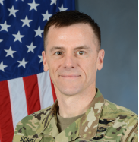
Colonel Matthew Schell
Arctic Security Advisor to the Adjutant General, Alaska
Alaska National Guard
Joint Base Elmendorf-Richardson, Alaska
matthew.c.schell.mil@army.mil

Colonel Matthew Schell, serves as an advisor to the Adjutant General of the Alaska National Guard on Arctic Security and Defense. Schell is a 28 year veteran of the United States Army. He is a graduated brigade commander after deploying the 297th Regional Support Group to Poland in support of European Deterrence Initiative in 2020-2021. He is currently the lead action officer for the National Guard Arctic Interest Council (NGAIC). His efforts include collaboration with 18 NGAIC states and National Guard Bureau to develop the National Guard Arctic strategy implementation plan which coordinates and synchronizes National Guard efforts at the state and national levels in support of DoD and service Arctic strategies.

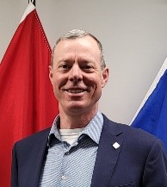
Conrad Schubert
Intergovernmental Affairs
Joint Task Force North
Yellowknife, NWT
Conrad.schubert2@forces.gc.ca

Conrad Schubert is the Advisor to the Commander Joint Task Force North with a broad remit to include relations with Indigenous, territorial and federal governments, their departments and agencies. He has spent the last 22 years working in Team North and traveling throughout the Canadian North as both an infantry officer and now as a civilian. He spent nine years at 1 Canadian Ranger Patrol Group headquarters in Yellowknife gaining insight into the essential relationship between the Canadian Armed Forces and the Indigenous people of the North. He then raised C Company of the Loyal Edmonton Regiment and served as officer commanding both full-time and later part-time until 2015, looking at the equipment, tactics and priorities of the Canadian army in the North. Concurrent with that he worked as intergovernmental affairs advisor, civil-military cooperation officer and NWT liaison officer at Joint Task Force North. Since 2016 he has focused on civil-military engagement and extending JTFN’s relationships with Alaska Command, with Danish Joint Arctic Command in Nuuk, Greenland and with Canada’s allies and partners in the Arctic Council. Since 2020 he has served as lead planner for the Arctic Security Working Group drawing together the whole of government with academia and NGOs to examine factors of human security in the Canadian Arctic.

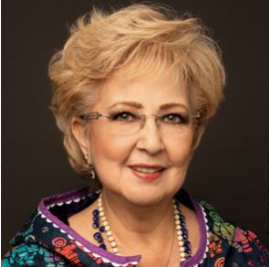
Gail R. Schubert
President & CEO
Bering Straits Native Corporation (BSNC)
gschubert@bsnc.net

Gail R. Schubert is the President & CEO of Bering Straits Native Corporation (BSNC), an Alaska Native regional corporation serving 17 villages in the Bering Strait region. She is Iñupiaq and was born and raised in Unalakleet, Alaska. In addition to serving as President & CEO of BSNC, she serves on the boards of the Alaska Federation of Natives, Alaska Native Justice Center, ANCSA Regional Association, Commonwealth North, the Iditarod Trail Committee, State of Alaska Renewable Energy Fund Advisory Committee, the Native American Contractors Association and the University of Alaska Foundation. She has served on the BSNC Board of Directors since 1992.
Schubert joined BSNC in 2003. Schubert is an ATHENA Society awardee, recipient of the Northwest Indian Bar Association’s Unsung Hero Award, and YWCA Alaska/BP Woman of Achievement Awardee for her leadership and excellence in her professional and personal endeavors, as well as her contributions to the larger community. Prior to joining BSNC, Schubert practiced law in Anchorage after a career on Wall Street, where she worked at the Federal Reserve Bank of New York and two Wall Street law firms. She earned an undergraduate degree from Stanford University, a Master of Business Administration from Cornell University's Johnson School of Management, and a Juris Doctorate from the Cornell University School of Law.

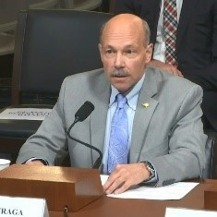
Dr. Mike Sfraga
Chair of the United States Arctic Research
US Arctic Research Commission
Fairbanks, Alaska and Washington D.C.
mike.sfraga@arctic.gov

Dr. Mike Sfraga was appointed by President Joseph Biden as Chair of the United States Arctic Research on September 24, 2021. Dr. Sfraga is the founding director of the Polar Institute and served as the director of the Global Risk and Resilience Program at the Woodrow Wilson International Center for Scholars in Washington, DC. He currently serves as chair and distinguished scholar in the Polar Institute. An Alaskan and a geographer by training, his work focuses on the geography of the Arctic and Antarctic landscapes, and the impacts and implications of a changing climate on political, social, economic, environmental, and security regimes in the Arctic. Dr. Sfraga served as chair of the 2020 Committee of Visitors Review of the Section for Arctic Science (ARC), Office of Polar Programs, National Science Foundation, and currently serves on the Scientific Advisory Council of the Finnish Institute for International Affairs (FIIA), and the State Committee on Research (SCoR) for the state of Alaska. Sfraga previously served in several academic, administrative, and executive positions at the University of Alaska. Dr. Sfraga has testified before the U.S. Congress, maintains an active speaking and facilitation schedule, and his commentary has been featured in many major media outlets. He earned the first PhD in geography and northern studies from the University of Alaska Fairbanks.

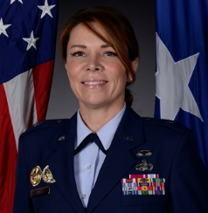
Brigadier General Tracy D. Smith
Assistant Adjutant General and Commander
Alaska Air National Guard
Joint Base Elmendorf-Richardson, Alaska

Brigadier General Tracy D. Smith serves as the Assistant Adjutant General and Commander, Alaska Air National Guard, Joint Base Elmendorf-Richardson, Alaska. She is responsible for the recruiting, retention, training, and equipping of over 2,400 Alaskan citizen airmen in two flying wings. She provides strategic airlift, search and rescue, aerial refueling, air defense, and space warning and surveillance capabilities in support of state and federal missions worldwide. Brigadier General Smith ensures the Alaska Air National Guard maintains a constant watch and commitment to Pacific Air Forces, Air Combat Command, United States Northern Command, United States Transportation Command, Alaska North American Aerospace Defense Command Region, and Air Force Space Command. Brigadier General Smith entered the United States Air Force in 1986 as a Medical Service Specialist. She received her commission from the United States Air Force Academy in 1994. After completion of Basic Personnel Officer's School, Brigadier General Smith served at Lackland Air Force Base, Texas, at the United States Air Force Academy, Colorado and at Eielson Air Force Base, Alaska. In 2001, she joined the Air Force Reserves and served as the 939th Rescue Wing in Portland before transitioning to the Air National Guard in 2004. Brigadier General Smith previously served at the squadron, group, wing, state, and national headquarters level. Prior to her current position, she was the Director for Integration, Office of the Deputy Assistant Secretary of Defense for Reserve Integration in the Office of Military and Reserve Affairs.

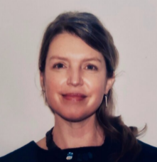
Claire Sneed
Senior Advisor and Consultant
U.S. Northern Command J5 Directorate
Peterson AFB, Colorado

Claire Sneed provides technical support in areas of assessment, program design, strategic planning, training and tool development, and evaluation. She works on issues related to governance reform, security, violence mitigation, P/CVE, and holistic approaches to various development challenges. Ms. Sneed is an international development and foreign policy specialist with 20 years of experience. She worked as a team lead, program manager, technical specialist, trainer, and analyst on topics including human security, local governance, conflict and violent extremism prevention, economic and social inclusion, and women, peace, and security.

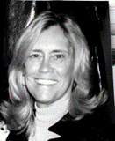
Catherine Ann Stevens, JD
Partner, Mayer Brown, LLP
Anchorage, Alaska and Washington D.C.

Catherine Ann Stevens, the wife of the late Senator Ted Stevens, is a fourth generation Alaskan who grew up in the territory and then State of Alaska. She has a long history of public service in addition to her legal career which includes State District Attorney Fourth Judicial District in Fairbanks, Assistant US Attorney in the Southern District of California and General Counsel to the National Endowment for the Arts. Catherine received a Presidential appointment as Commissioner to the Eisenhower Commission and Trustee for the Kennedy Center. The Senator and Catherine committed themselves to support the culture and well-being of Alaska Native people. Also, she with Senator Stevens, a veteran of WWII, constantly worked to improve the lives of our veterans and men and women in our military services. This includes support for TAPS, Thanks USA and the World War II Museum. Catherine was the proud sponsor for the USS Alaska (SSBN-732) a US Navy Ohio class ballistic missile submarine commissioned in 1986; the USCGC Healy (WAGB-20) ice breaker and polar research vessel; and now, she is the sponsor of the US Navy Destroyer, USS Ted Stevens (DDG128) to be christened in 2023.

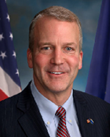
Honorable Senator Dan Sullivan (R-Alaska)

Senator Sullivan became Alaska’s eighth US Senator in January 2015. He serves on four Senate committees vital to Alaska: the Commerce, Science, and Transportation Committee; the Armed Services Committee; the Environment and Public Works Committee; and the Veterans’ Affairs Committee. Earlier, Senator Sullivan served as Alaska’s Attorney General where his number one priority was protecting Alaskans, their physical safety, financial well-being, and individual rights. As Commissioner of the Alaska Department of Natural Resources, Senator Sullivan man- aged one of the largest portfolios of oil, gas, minerals, renewable energy, timber, land, and water in the world. Senator Sullivan has a distinguished record of military and national security service. He is currently an infantry officer and Colonel in the US Marine Corps Reserves. He earned a bachelor’s degree in economics from Harvard University in 1987 and a joint law and Master of Science in Foreign Service from Georgetown University in 1993.

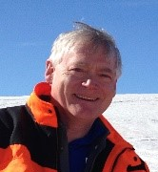
Hon. Mead Treadwell, former Lt. Governor, Alaska (2010-2014)
Co-Chair, Wilson Center Polar Institute Advisory Board
Washington, DC
Chair/CEO, Qilak LNG
Anchorage, Alaska
mead@treadwellalaska.com

Mead Treadwell co-chairs the Wilson Center Polar Institute Advisory Board in Washington, DC and is Chair/CEO of Qilak LNG in Anchorage, Alaska, a $5 billion LNG export project in development. He chairs NASDAQ-listed Iridium’s Polar Advisory Board and is an elected director of the Explorers Club. Treadwell was elected Lt. Governor of Alaska 2010-2014 and appointed Chair of the U.S. Arctic Research Commission (USARC) under Presidents George W. Bush and Barak Obama, 2006-2010 and a USARC Commissioner, 2001-2010. There, he helped draft current US Arctic Policy and funded the eight-nation Arctic Council’s Arctic Marine Shipping Assessment. For Iceland-based NGO Arctic Circle, he chaired a mission council on Arctic shipping and ports. He was named by Governor Michael Dunleavy to a follow-on federal advisory committee on Arctic shipping created by Congress at USDOT. Treadwell was Managing Director and Senior Fellow at the Institute of the North, 1997-2010, founded by Alaska’s second Governor Walter J. Hickel, where he helped found the Independent Working Group on Missile Defense. He has been deeply involved in circumpolar cooperation for over 40 years. A graduate of Yale College and Harvard Business School, Treadwell is father of three grown children (including a First Lieutenant USMC) and is married to Virginia Clay McClure.

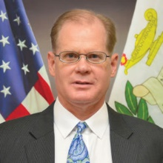
CAPT (Ret) Wade Turvold
Professor
Daniel K. Inouye Asia-Pacific Center for Security Studies
Honolulu, Hawaii
wade.d.turvold.civ@apcss.dsca.mil

Captain Wade Turvold, United States Navy (Retired) serves as a Professor at the Daniel K. Inouye Asia-Pacific Center for Security Studies in Honolulu, Hawaii. He focuses on maritime security, Russia, Japan, and Northeast Asia. He leads the Maritime Security Working Group and has organized numerous courses and workshops on the topic. He also focuses on Russia in the Indo-Pacific region, as well as on Japan and Northeast Asia.

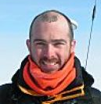
Dr. Craig Tweedie
Professor
Department of Biology
University of Texas at El Paso (UTEP)

Dr. Craig Tweedie is a Professor with the Department of Biology and Directs the Environmental Science and Engineering Program at The University of Texas at El Paso (UTEP). Tweedie earned his PhD in subantarctic climate change biology and switched to Arctic terrestrial ecology when he began his postdoc at Michigan State University in 2000. With many active collaborations both in the US and internationally, Tweedie maintains an active research program that is focused on land cover change and the impact this has on terrestrial and coastal ecosystem structure and function in the north Alaskan and Beringian Arctic and in the Chihuahuan Desert. Tweedie also has strong interests in education and outreach and the use of cyberinfrastructure to advance environmental Science.

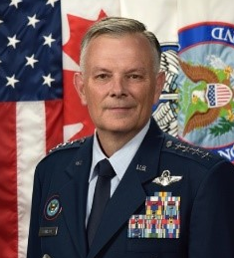
Gen Glen VanHerck
Commander
North American Aerospace Defense Command
and U.S. Northern Command
Peterson AFB, Colorado Springs, CO
U.S. Department of Defense

General Glen VanHerck is Commander, North American Aerospace Defense Command (NORAD) and United States Northern Command (USNORTHCOM). NORAD conducts aerospace warning, aerospace control, and maritime warning in the defense of North America. USNORTHCOM conducts homeland defense, civil support, and security cooperation to defend and secure the United States and its interests. General VanHerck is a graduate of the University of Missouri and was commissioned through the Reserve Officer Training Corps program. He has a diverse operational and training background that includes assignments in the F-15C, F-35A, B-2A, and B-1B with over 3,200 flight hours. He has served as an instructor pilot and flight examiner in the F-15C, B-2A, and T-6A. Additionally, he served as a U.S. Air Force Weapons School instructor in the F-15C and the B-2A. He has commanded at the squadron, group and twice at the wing level, including the 325th Weapons Squadron, the 71st Operations Group, the 7th Bomb Wing, the 509th Bomb Wing. As a Major General, he commanded the U.S. Air Force Warfare Center. His staff assignments include tours as the Chief of the B-2 Program Element Monitor at Headquarters Air Combat Command, the Director of Operations at Headquarters Air Force Global Strike Command, the Director of Plans and Integration at U.S. Strategic Command, the Vice Director of Strategy, Plans and Policy (J5) at the Joint Staff, and the Vice Director then Director of the Joint Staff. His USAF biography is located at: https://www.af.mil/About-Us/Biographies/Display/Article/467046/general-glen-d-vanherck/

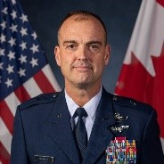
Brig Gen Edward “Hertz” Vaughan
J5 Deputy Director
European Command
Stuttgart, Germany

Brig Gen Edward “Hertz” Vaughan serves as Deputy Director for Security Cooperation, Partnering, Policy and Space Capabilities, J5, U.S. European Command, Stuttgart, Germany. He is responsible for facilitating policy, plans, activities, and investments that enhance security relationships and partnerships across Europe, with special emphasis on the Arctic, the Baltics, and the Black Sea regions. Brig Gen Vaughan also co-chairs the Arctic Security Forces Roundtable, the only Arctic forum focused on security forces operating in the Arctic region.

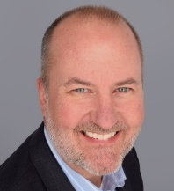
Eric Velte
Senior Vice President and Chief Technology Officer
ASRC Federal

Eric Velte is ASRC Federal’s Senior Vice President and Chief Technology Officer. With more than 25 years of experience in computer science and technical solutions in support of critical customer missions, Eric has overseen the research, development and delivery of technical products and services across the federal government spectrum in the fields of Information Technology, Software, Engineering, Base and Facility Operations, and Professional Services. Eric received his bachelor’s degree in history from Ursinus College and his master’s degree in computer science from Rowan University. ASRC Federal is a family of companies that provides a wide array of services to a broad base of federal government agencies, including the areas of Space, Defense and Intelligence, Civilian and Health.

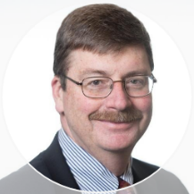
CAPT(ret) Mike White, USCG
Maritime Advisor
Pacific Northwest National Laboratory
Walla Walla, WA
Michael.f.white@pnnl.gov

Captain Mike White, USCG (ret) serves as the Maritime Advisor in the National Security Directorate of the Department of Energy’s Pacific Northwest National Laboratory. He arrived at PNNL in 2015 following a 30+ year CG career focused on operations and interagency coordination that included patrols in the Bering Sea and small craft operations in the Beaufort Sea. He now serves PNNL’s National Security Directorate as the Borders and Maritime Subsector Manager, a project manager for critical infrastructure protection, resiliency advisor for international partners, aquatic programs Subject Matter Expert, and as an autonomous vessel operator.


Ms. Sheyna Wisdom
Executive Director
Alaska Ocean Observing System (AOOS)
Anchorage, Alaska
wisdom@aoos.org

Sheyna Wisdom is the Executive Director of the Alaska Ocean Observing System (AOOS), the Alaska regional component of the national Integrated Ocean Observing System (IOOS). AOOS works collaboratively to identify and fill gaps in ocean information and provide accurate and reliable data, applications and services for decision making. Prior to joining AOOS in 2021, she was an environmental consultant for 18 years with an emphasis in large scale program management, permitting and compliance, and research. Wisdom has managed a multitude of projects across Alaska, including an artificial polar bear den detection study, marine ecosystem studies in the Chukchi and Beaufort seas, and marine mammal monitoring projects in Cook Inlet, Prince William Sound, and the Arctic. In addition to having extensive experience in Arctic logistics, vessel management, and permitting, she has developed strong relationships with coastal communities across the Alaskan Arctic and looks forward to working in this role to promote collaboration.

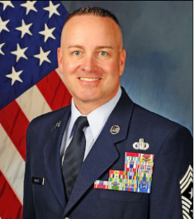
Chief Master Sergeant David R. Wolfe
Senior Enlisted Leader, Alaskan NORAD Region, Alaskan Command
Command Chief Master Sergeant, Eleventh Air Force
Joint Base Elmendorf-Richardson, Alaska

Chief Master Sergeant David R. Wolfe is assigned as the Senior Enlisted Leader of the Alaskan NORAD Region, Alaskan Command, and the Command Chief Master Sergeant, Eleventh Air Force; Joint Base Elmendorf-Richardson, Alaska. He directly supports the mission of providing the Pacific and Northern Command combatant commanders, and Pacific Air Forces’ commander with ready forces and infrastructure for homeland defense, decisive force projection, and defense support to civil authorities, when requested. He facilitates mission requirements and advises the commander on matters of force utilization, morale, and welfare of the Soldiers, Airmen, Sailors, Marines, and Coast Guardsmen and their families assigned throughout the Alaska Joint Operations Area, Hawaii and Guam. Chief Wolfe entered the Air Force in February 1992. His background includes missile security, elite guard, protective services, space warning security, training and standardization evaluation, security forces operations, logistics, professional military education, and security forces pre-deployment sustainment training. Chief Wolfe has served in Wyoming, Alaska, Illinois, and Florida, as well as overseas in Italy and Germany. He has deployed in support of Operation SOUTHERN WATCH, IRAQI FREEDOM, and INHERENT RESOLVE.

